# Council assessment Report

|  |  |
| --- | --- |
| **Panel Reference** | PPS-2018SSW028 |
| **DA Number** | 2255/2018/DA-C |
| **LGA** | Campbelltown City Council |
| **Proposed Development** | Proposed Sports and Health Centre of Excellence Building and associated drainage, car parking, landscaping and signage |
| **Street Address** | Lots 3098 DP 1230014, Goldsmith Avenue, Campbelltown |
| **Applicant/Owner** | Campbelltown City Council – Applicant  Western Sydney University – Owner |
| **Date of DA Lodgement** | 28 June 2018  Amended Plans lodged 14 May 2020 |
| **Number of Submissions** | Original Notification 20 August 2018 to 24 September 2018 - One (1) submission received  Re-notification 19 July 2020 to 17 August 2020 – No submissions received |
| **Recommendation** | Approval |
| **Regional Development Criteria (Schedule 4A of the EP&A Act)** | Development on Council land over $5 million |
| **List of All Relevant s79C(1)(a) Matters** | * Environmental Planning and Assessment Act 1979 * Water Management Act 2000 * Environmental Protection & Biodiversity Conservation Act 1999 * NSW Biodiversity Conservation Act 2016 * Planning for Bush Fire Protection 2019 * State Environmental Planning Policy 33 – Hazardous and Offensive Development * State Environmental Planning Policy 55- Remediation of Land * State Environmental Planning Policy (Infrastructure) 2007 * State Environmental Planning Policy (Vegetation in Non-Rural Areas) 2017 * State Environmental Planning Policy 64 – Advertising and Signage * State Environmental Planning Policy 19 – Bushland in Urban Areas * State Environmental Planning Policy (Koala Habitat Protection) 2019 * Greater Metropolitan Regional Environmental Plan No. 2 –Georges River Catchment * Campbelltown Local Environmental Plan 2015 * Campbelltown (Sustainable City) Development Control Plan 2015 |
| **List all documents submitted with this report for the panel’s consideration** | * Assessment report and conditions * Statement of Environmental Effects * Clause 4.6 Variation request * Architectural Plans * Landscape Plans * Preliminary Site Investigation * Geotechnical Report * Stormwater Management Plan * Traffic Report * Acoustic Report * Waste Management Plan * BCA Assessment Report * Ecological Advice * Bushfire Hazard Assessment * Aboriginal Due Diligence |
| Report by | Donna Clarke – Land Dynamics Australia Pty Ltd |
| Report date | 4 December 2020 |

|  |  |  |
| --- | --- | --- |
| **Summary of 4.15 matters**  Have all recommendations in relation to relevant 4.15 matters been summarised in the Executive Summary of the assessment report? | | **Yes** |
| **Legislative clauses requiring consent authority satisfaction**  Have relevant clauses in all applicable environmental planning instruments where the consent authority must be satisfied about a particular matter been listed, and relevant recommendations summarised, in the Executive Summary of the assessment report?  *e.g. Clause 7 of SEPP 55 - Remediation of Land, Clause 4.6(4) of the relevant LEP* | | **Yes** |
| **Clause 4.6 Exceptions to development standards**  If a written request for a contravention to a development standard (clause 4.6 of the LEP) has been received, has it been attached to the assessment report? | | **Yes** |
| **Special Infrastructure Contributions**  Does the DA require Special Infrastructure Contributions conditions (S94EF)?  *Note: Certain DAs in the Western Sydney Growth Areas Special Contributions Area may require specific Special Infrastructure Contributions (SIC) conditions* | **No** | |
| **Conditions**  Have draft conditions been provided to the applicant for comment?  *Note: in order to reduce delays in determinations, the Panel prefer that draft conditions, notwithstanding Council’s recommendation, be provided to the applicant to enable any comments to be considered as part of the assessment report* | | **Yes** |

**Executive Summary**

The application proposes the following works:

* Proposed Construction of a two storey building for use as a Sports and Health Centre of Excellence Building (CoE);
* Associated drainage, car parking, landscaping and signage.

The site is located off Goldsmith Avenue within the master planned community of Macarthur Heights and is currently vacant land. The proposed development will occupy a portion of the larger site only and will be dedicated to Council as per an existing Planning Agreement in place.

The application indicates that the purpose of the proposed development is to address a demand for elite sporting facilities while also addressing the lack of community sports facilities in the region. The CoE will provide elite sports training and community sports facilities, administration and operational spaces with community spaces and special-use programs, as well as a fully functional Community Health Centre and sports science research facility, within a community hub model. Vehicular access is proposed to the development via Goldsmith Avenue.

Throughout the assessment, amended plans were provided and re-exhibited.

The cost of works proposed under the application is $29.2 million.

The site is owned by Western Sydney University (WSU) and will be dedicated to Council after the development is completed, by way of a separate application to excise off the CoE development. This application has been independently assessed given that the site is to be dedicated to, and owned by, Campbelltown City Council.

This application has been assessed against the provisions of Section 4.15 of the Environmental Planning and Assessment Act 1979. Having regard to these provisions, the application has been found to be satisfactory. The proposal has been found to satisfy the relevant State Environmental Planning Policies. In particular, pursuant to clause 7 of State Environmental Planning Policy 55 – Remediation of Land, information has been provided that demonstrates that the site is suitable for the proposed development. The proposal would also satisfy the relevant provisions of Campbelltown Local Environmental Plan 2015 and Campbelltown Development Control Plan 2015. A Clause 4.6 Variation to Council’s height controls under Campbelltown Local Environmental Plan 2015 has been supported.

It is considered that the overall social and economic impacts of the proposed development would be positive, and that potential impacts on the natural and built environments will be mitigated through design measures and the imposition of specific conditions of consent. High quality landscaping is proposed around all sides of the building.

The application was publicly exhibited and notified to surrounding residents, and no submissions were received. Following the receipt of amended plans, the proposal was re-exhibited, and no submissions were received.

The site’s location, zoning and existing land use make it suitable for the proposed development, and the proposal is in the broad interests of the general public.

**1. Application Overview**

**1.1 The Site and Locality**

The site is identified as Lots 3098 DP 1230014, Goldsmith Avenue, Campbelltown. The overall site is irregular in shape; however the proposed development relates to a smaller portion only which has an area of approx. 1.354ha and is on the southern side of Goldsmith Avenue. The topography of the site will be altered as part of a bulk earthworks approval under DA 1768/2015.

The site is currently vacant and is traversed by concrete channelled Bow Bowing Creek to the southern part of the site. The site is generally clear of vegetation with a remnant pocket of Cumberland Plain Woodlands to the north and north-east of the development.

Surrounding development comprises low to medium density residential development, within the Macarthur Heights master planned estate. These residential areas on the northern side of Goldsmith Avenue are currently under construction. Western Sydney University (WSU) Campbelltown campus is located to the north/north-east of the site on the northern side of Goldsmith Avenue.

The area of Macarthur Heights is bounded by Narellan Road to the north and east, the Main Southern railway line to the south and Hume Motorway (M31) to the west and north-west.

The site is within walking distance of Macarthur Station and Macarthur Square Shopping Centre and further to the east of the site is Campbelltown Railway Station, Campbelltown Mall and Campbelltown Sports Stadium. Bus interchanges are located at both railway stations and Campbelltown Hospital

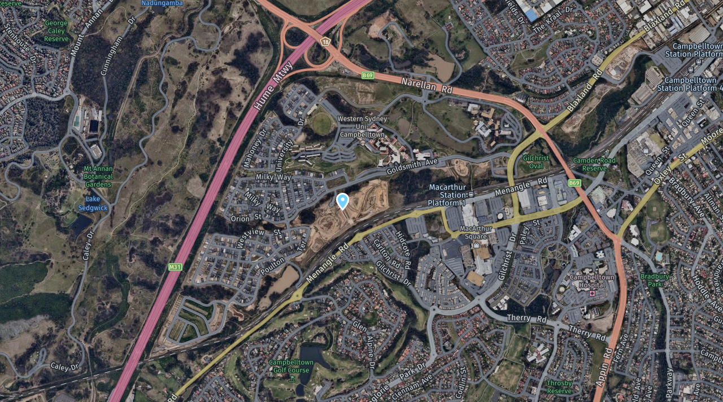

Figure 1: Locality Map

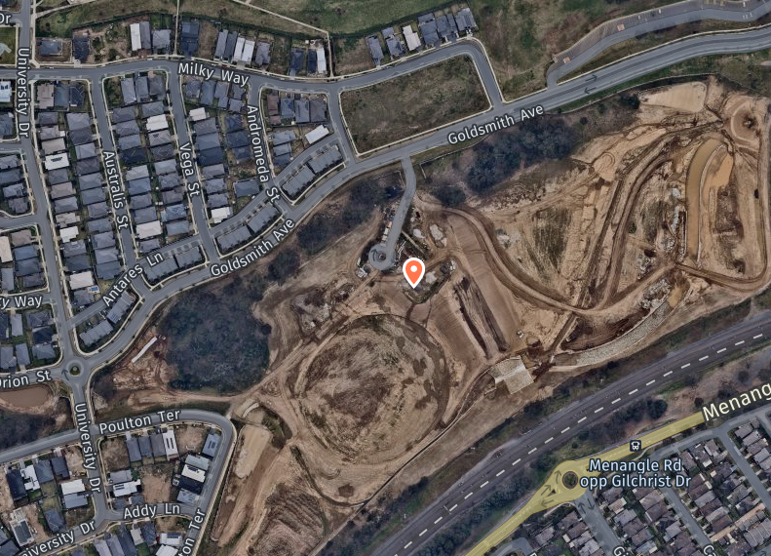

Figure 2: Site Map

The site has access from Goldsmith Avenue already via a previous driveway.

Immediately north and north-east of the development area is remnant Cumberland Plain Woodlands (CPW), subject of a Vegetation Management Plan. Directly south of the development area is the concrete channelled Bow Bowing Creek and the Main Southern railway line. The development site is located approximately 60 m from the natural watercourse to the south and a watercourse is also located in the northern area of the site.

**1.2 Proposal**

The applicant has sought development consent for the construction of a Proposed Sports and Health Centre of Excellence Building and associated drainage, car parking for 120 vehicles, landscaping and signage.

The application details that the proposed CoE will contain a mix of sports and community related facilities and will promote sporting participation, health and wellbeing in a community hub model. Council will be responsible for maintaining the development, including the security and safety of the building, management of staff, management of the sporting/training programs, management of deliveries and maintaining the quality of the building. The CoE will operate as a controlled, multiuse environment and will provide the following:

* Gymnasium and fitness studios
* Recovery and program pool being 8m x 15m
* Indoor sports hall containing two sports courts and store rooms for equipment
* Amenities
* Community health centre and clinical rooms on the first floor, in partnership with WSU
* Social club room and meeting rooms
* Office, administration, storage and staff facilities
* Café being 40m² in area without cooking facilities
* Plant and equipment rooms
* New access driveway
* Controlled car park containing a total of 120 car spaces, including 4 accessible spaces
* Bin store and waste collection area
* Loading Zone

The building has a gross floor area of 7,080m². Vehicular access is proposed to the development via construction of a new two-way access driveway off Goldsmith Avenue and an internal roundabout. The new driveway is proposed to the west of the existing driveway and will provide access to both the playing fields (separate approval) and the CoE building. Adjacent to the roundabout is a designated bus parking/queuing and drop-off zone. A ‘kiss and drop’ zone is also located immediately at the front of the building. The existing redundant footway crossing on Goldsmith Avenue will be replaced with kerb and gutter, and the footway area will be restored.

The appearance of the building is contemporary and suited to the emerging precinct. The materials and finishes of the proposed building include large areas of glazing and a mixture of brickwork, precast concrete panels, painted surfaces and colorbond.

The proposal includes a landscape scheme around the perimeter of the building and within the CoE development site, which incorporates a variety of trees and shrubs, with an emphasis on native species. One (1) Eucalyptus moluccana tree located at the driveway entrance is proposed to be removed. A further twelve (12) small trees/shrubs will also be removed to accommodate the proposed new car parking area. It is proposed that replacement tree planting, in the form of shade trees within the car park, along the entry driveway and on the western side of the building, will be provided. An informal seating area is located on the western side of the building next to the car park.

A secure open-air bin enclosure is proposed on the northern side of the car park adjacent to the roundabout. The bin enclosure will accommodate bins for general waste, recyclables, general/green waste, and medical waste.

Security gates, lighting and CCTV attached to the exterior of the CoE building. The proposed hours of operation comprise 5am to 12am midnight, 7 days a week.

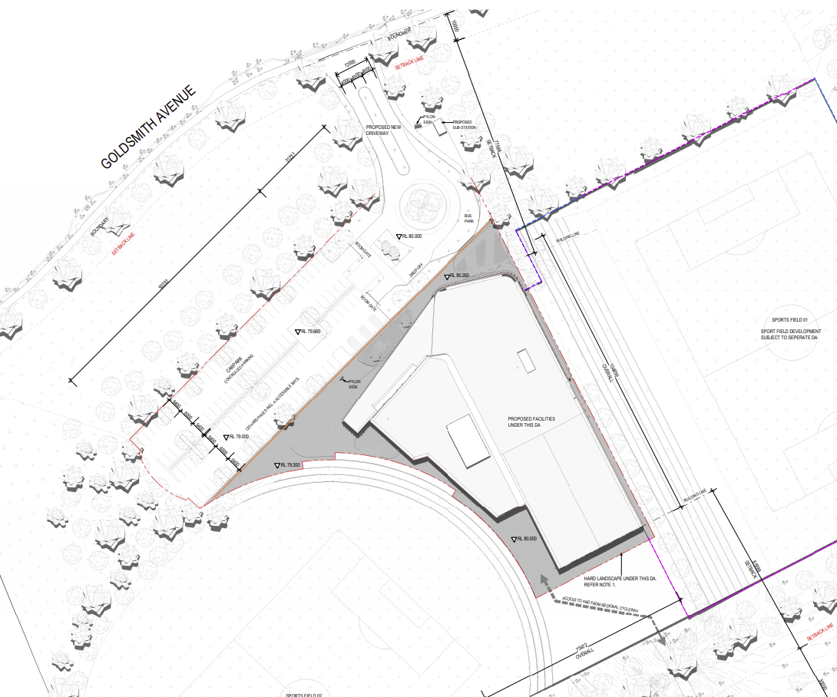

Figure 3: Proposed Site Plan

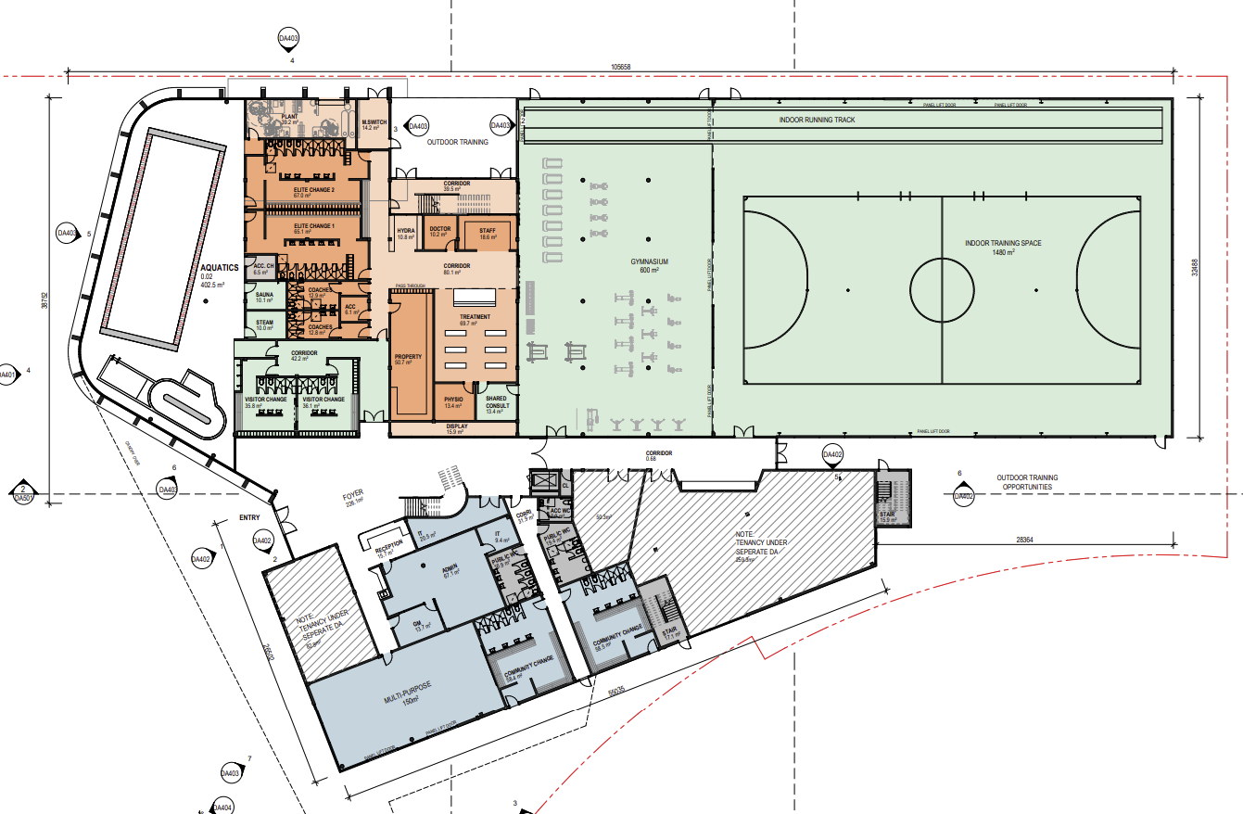

Figure 4: Proposed Building Layout – Ground Floor

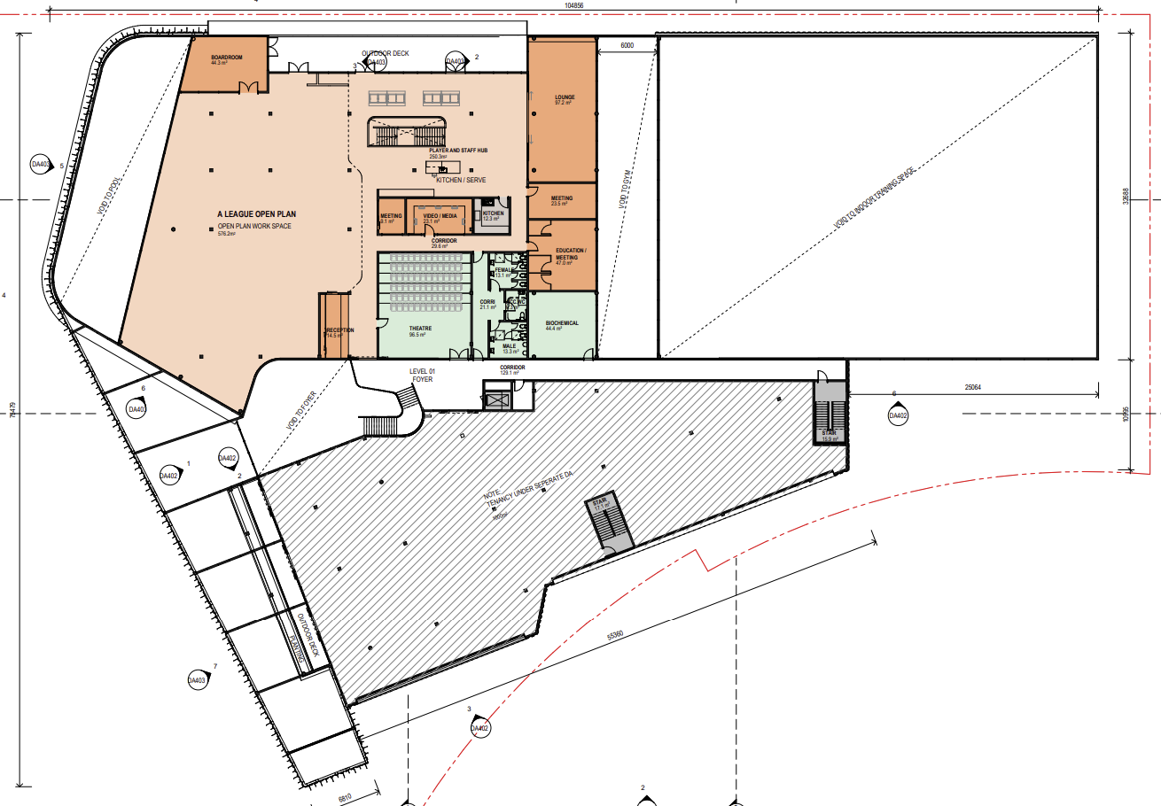

Figure 5: Proposed Building Layout – First Floor

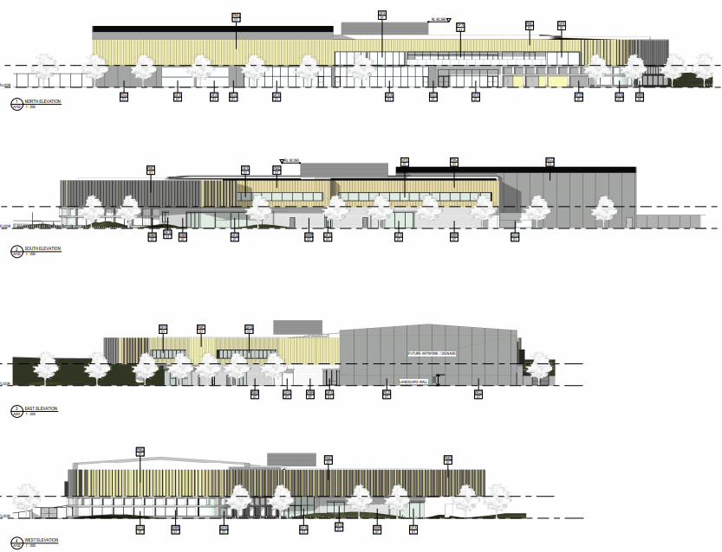

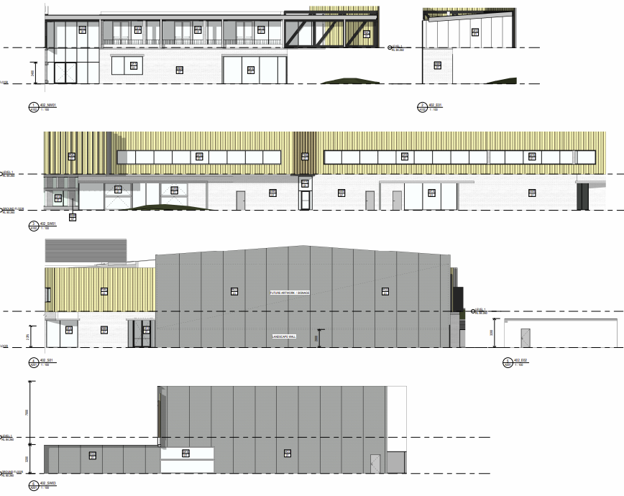

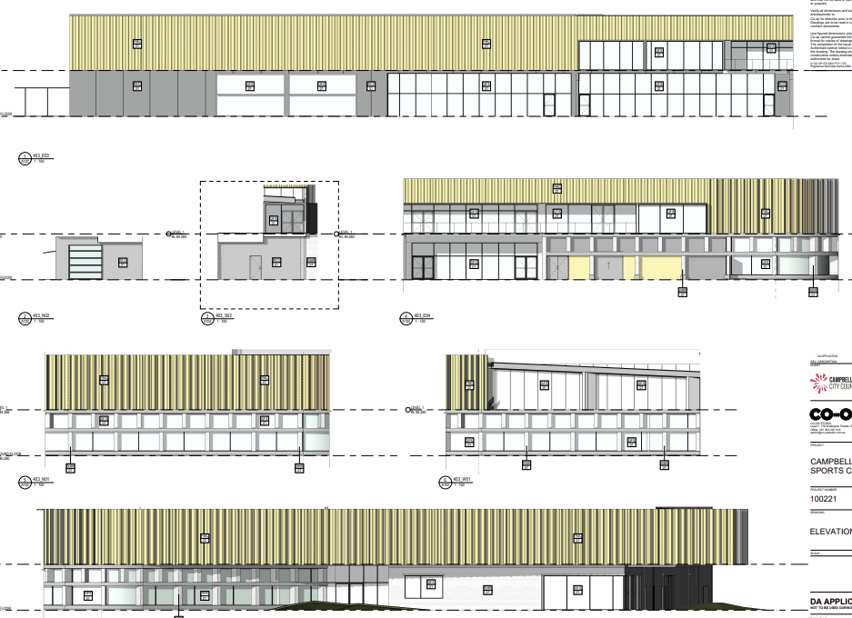

Figure 6: Elevations

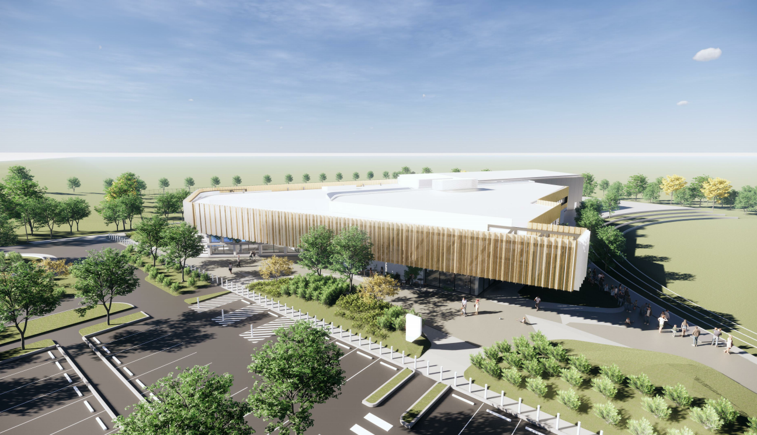

Figure 7: Photomontage

Signage is proposed to the car park which comprises two (2) pylon signs as follows:

* Sign 1 - 2.5m wide x 6m high backlit illuminated tenant sign
* Sign 2 - 1.5m wide x 2.5m high backlit illuminated tenant sign

The application details that:

* The building is proposed to be constructed at RL 80.26m AHD
* The car park at RL 80.00 – RL 78.50m AHD.
* The existing levels of Goldsmith Avenue at the entry to the site is RL 84.80m AHD.
* The proposed playing fields adjacent to the CoE will be located at RL 77.00m AHD to the west of the site and RL 76.50m AHD to the east.

The application confirms that the following works are subject to separate development applications:

* All demolition works
* Fit out of the community health centre
* Land excavation and cut/fill activities
* Fencing and retaining walls
* Subdivision

**1.3 Site History**

DA 845/2015/DA-CW was approved by Council on 22 December 2016 for bulk earthworks and drainage works on the site, with the extent of works is limited to the area of the training/playing fields only. The application confirms that this approval excludes any works within the proposed Campbelltown Sports and Health CoE development area.

DA 1768/2015/DA-SW was approved by Council on 29 October 2020 for the construction of two sports fields, associated landscaping, civil works, vegetation management and rehabilitation works and Torrens Title subdivision to create an allotment for a telecommunications facility. The application confirms that this approval excludes any works within the proposed Campbelltown Sports and Health CoE development area.

**1.4 Application History**

The application was briefed to the Sydney Western City Planning Panel on 29 October 2018. The Panel resolved to allow electronic determination of this application.

**1.5 Vision - Campbelltown 2027**

Campbelltown 2027 is the Community Strategic Plan (CSP) for the city of Campbelltown. Campbelltown 2027 addresses four key strategic outcomes that Council and other stakeholders will work to achieve over the next 10 years:

• Outcome 1: A vibrant, liveable city

• Outcome 2: A respected and protected natural environment

• Outcome 3: A thriving, attractive city

• Outcome 4: A successful city

Outcomes 1, 3 and 4 are the most relevant to the proposed development.

The strategy relevant to this application is as follows:

1.2- Create safe, well maintained, activated and accessible public spaces.

3.2 – Ensure that service provision supports the community to achieve and meets their needs.

3.4 – Retain and expand existing businesses and attract new enterprises to Campbelltown, offering opportunities for a diverse workplace including professional, technology and knowledge based skills and creative space.

3.7- Public funds and assets are managed strategically, transparently and efficiently.

4.4- Maintain and create usable open and recreational spaces that set our city apart from others.

The proposed development provides a revitalisation of a disused recreational space, which was envisaged as part of the master planning of the area and responds to the need for recreation and sporting facilities. The co-location of the CoE with proposed new sports fields contributes to the creation of a community precinct with a focus on encouraging physical activity and improving health. The development site is located close to existing and future residential development, within walking distance of public transport, and will operate in conjunction with WSU.

The design of the overall area will provide for connectivity for pedestrians throughout the various recreational uses in an accessible manner and provides activated areas and connection to the regional cycleway. Once developed, the facility will be dedicated to Council.

The proposal will provide for employment within the local community. The proposed development will contribute to the economic and employment growth in the City of Campbelltown, as well as the significant boost to the local construction industry.

## Report

The development has been assessed in accordance with the matters of consideration under Section 4.15 of the Environmental Planning and Assessment Act, 1979, having regard to those matters, the following issues have been identified for further consideration.

**2. Section 4.15(1)(a)(i) Any Environmental Planning Instruments**

**2.1 Water Management Act 2000**

### The subject site has Bow Bowing Creek located on the southern parts of the site. The approved DA for Bulk Earthworks and Drainage (854/2015/DA) constituted “Integrated Development” given that works were proposed within 40m of Bow Bowing Creek. The Office of Water’s General Terms of Approval were granted and formed conditions of consent.

### The subject application is not considered to be “Integrated Development” pursuant to Section 4.46 of the Environmental Planning and Assessment Act 1979, as it does not involve works within 40 metres of an existing watercourse.

**2.2 NSW Biodiversity Conservation Act 2016 & Commonwealth Environment Protection and Biodiversity Conservation Act 1999**

The development portion of the lot subject to this application includes limited vegetation. The proposal includes removal of one (1) Eucalyptus moluccana tree located at the driveway. A further twelve (12) small trees/shrubs will also be removed to accommodate the proposed new car parking area. It is proposed that replacement tree planting, in the form of shade trees within the car park, along the entry driveway and on the western side of the building, will be provided. Feature trees will also be located at the front of the building. The remaining vegetation located adjacent to Goldsmith Avenue, but outside of the subject development area, will be retained and tree protection zones will be provided during construction to protect this vegetation. As part of the Macarthur Heights master planning, ecological impacts were considered and the site is also subject to a Vegetation Management Plan as part of the master planning of the area.

As such, it is not envisaged that there are any ecological issues pertaining to the site.

**2.3 Planning for Bush Fire Protection 2019**

The site is identified as bushfire prone land and the application was accompanied by a Bushfire Hazard Assessment Report which identifies the proposed development site as BAL-LOW and does not require any specific construction methods; identifies planned asset protection zones has been satisfactory; and concludes that the proposal is capable of meeting the planning requirements of Planning for Bush Fire Protection.

**2.4 State Environmental Planning Policy 33 – Hazardous and Offensive Development**

The proposed use of the site would result in the storage of potentially hazardous chemicals associated with the pool. The applicant has addressed the proposed storage of goods and identifies that the development is not industry or storage establishment and does not require a licence. Further, as the development is not for an industrial purpose and does not exceed the thresholds under SEPP 33 to constitute potentially hazardous or offensive industry. Therefore, it is agreed that a Preliminary Hazard Analysis (PHA) is not required in this instance.

### 2.5 State Environmental Planning Policy 55 - Remediation of Land

SEPP No. 55 aims to provide a state-wide planning approach to the remediation of contaminated land. In particular the policy aims to promote the remediation of contaminated land in order to reduce the risk of harm to human health or any other aspect of the environment. It requires the consent authority to consider whether the subject land is contaminated when determining a development application. If the land is contaminated, the consent authority must be satisfied that the land is suitable in its contaminated state (or will be suitable, after remediation) for the purpose for which the development is proposed to be carried out.

A Preliminary Site Investigation (PSI) prepared by Douglas Partners was undertaken over the site, which included a review of previous uses and 16 test pits and sampling and analysis. The report includes the following conclusion and recommendations:

*“Based on the findings of this investigation, DP concludes that the potential for contamination constraints to the proposed development is low.”*

The report also recommends a hazardous building aerials survey prior to demolition and sampling afterwards. This will be recommended on the application for demolition; however a condition has also been included on this application to ensure it occurs prior to this development occurring.

Accordingly, pursuant to clause 7 of the SEPP, it is considered that the site is suitable for the proposed development, being for a bulky goods premises and conditions are recommended.

**2.6 State Environmental Planning Policy (Infrastructure) 2007**

The purpose of the State Environmental Planning Policy (Infrastructure) 2007 is to facilitate the effective delivery of infrastructure across the state.

1. *Permissibility*

Clause 57(1) of the SEPP allows a ‘health services facility’ within the R3 zone. This application relies upon permissibility for this component of the development under the SEPP.

1. *Development Adjacent to Rail Corridors*

The proposed works are located over 100m from the adjacent railway corridor. The nature of the development does not trigger the requirements of Clause 87 and as such no further consideration is to be given to the impact or rail noise or vibration.

1. *Traffic Generation*

Clause 101 of the SEPP states:

*“101   Development with frontage to classified road*

*(1)  The objectives of this clause are:*

*(a)  to ensure that new development does not compromise the effective and ongoing operation and function of classified roads, and*

*(b)  to prevent or reduce the potential impact of traffic noise and vehicle emission on development adjacent to classified roads.*

*(2)  The consent authority must not grant consent to development on land that has a frontage to a classified road unless it is satisfied that:*

*(a)  where practicable and safe, vehicular access to the land is provided by a road other than the classified road, and*

*(b)  the safety, efficiency and ongoing operation of the classified road will not be adversely affected by the development as a result of:*

*(i)  the design of the vehicular access to the land, or*

*(ii)  the emission of smoke or dust from the development, or*

*(iii)  the nature, volume or frequency of vehicles using the classified road to gain access to the land, and*

*(c)  the development is of a type that is not sensitive to traffic noise or vehicle emissions, or is appropriately located and designed, or includes measures, to ameliorate potential traffic noise or vehicle emissions within the site of the development arising from the adjacent classified road.”*

Menangle Road is classified as a state road; however, the proposed development does not include vehicular access to Menangle Road. The proposed development is not considered to compromise the ongoing operation of Menangle Road, as evidenced by the traffic report submitted in support of the proposed development.

Council’s City Delivery Section reviewed the proposal and raised no objection.

**2.7 State Environmental Planning Policy (Vegetation in Non-Rural Areas) 2017**

The State Environmental Planning Policy (Vegetation in Non-Rural Areas) 2017 works together with the Biodiversity Conservation Act 2016 and the Local Land Services Amendment Act 2016 to create a framework for the regulation of clearing of native vegetation in New South Wales.

The Policy applies to the Campbelltown Local Government Area, including (in part) land zoned R3 Medium Density Residential. In considering the site, it is noted that it is identified in the Native Vegetation Regulatory Map as ‘Land Excluded from the LLS Act’. The proposal involves the removal of one tree on land identified in the Biodiversity Values (BV) Map as having ‘high biodiversity value’. Notwithstanding this, the threshold for clearing is not met with the tree removal. It is concluded that the site is not subject to the Biodiversity Offsets Scheme.

**2.8 State Environmental Planning Policy 64 – Advertising and Signage**

The application has been assessed having regard to State Environmental Planning Policy No. 64 – Advertising and Signage (SEPP 64). Parts 1 and 2 of the SEPP apply. Part 3 does not apply as the signage could be deemed “business identification signs” or “building identification signs”. This application sets up the pylon sign with room for future tenants to provide the name of the business or logo, but will not include advertising. The signage was added after lodgement of the application.

Signage is proposed to the car park which comprises two (2) pylon signs as follows:

* Sign 1 - 2.5m wide x 6m high backlit illuminated tenant sign
* Sign 2 - 1.5m wide x 2.5m high backlit illuminated tenant sign

Schedule 1 of SEPP 64 specifies the assessment criteria of signage under this instrument. The assessment considers the visual and environmental impact of the proposed signage, its impact upon the amenity of the surrounding locality and the potential traffic and safety hazards they may pose. The proposed development includes two pylon signs within the car parking area, which are assessed below:

***Schedule 1 – Assessment Criteria***

1 Character of the area

* Is the proposal compatible with the existing or desired future character of the area or locality in which it is proposed to be located?
* Is the proposal consistent with a particular theme for outdoor advertising in the area or locality?

**Comment** – There is no clear theme in the area, with a variety of land uses including recreation and the university. Whilst this site is zoned for residential purposes, the signs are located within the entry to and on the edge of the carpark, which is away from the residential dwellings. The site is adjoined by sporting fields and a treed area to the north. As such, the proposed signage which will identify the CoE and tenants is generally suitable for such a location and use. It is considered that the proposed signage will be compatible with character of the area.

2 Special areas

* Does the proposal detract from the amenity or visual quality of any environmentally sensitive areas, heritage areas, natural or other conservation areas, open space areas, waterways, rural landscapes or residential areas?

**Comment** – The proposed signage is located adjacent to the driveway and car parking area and is not considered to detract from the visual quality of the environment. The vegetated area to the north is not impacted upon by the proposed signage, nor are the residential dwellings and the proposed landscaping will assist to reduce the visual impact of the signage.

3 Views and vistas

* Does the proposal obscure or compromise important views?
* Does the proposal dominate the skyline and reduce the quality of vistas?
* Does the proposal respect the viewing rights of other advertisers?

**Comment** - The signage will not impact on any views or vistas in the locality. The visual impact of the development has been considered and given the presence of vegetation and distance to residential and that the proposed signage is setback approx. 25m from Goldsmith Avenue boundary, it is not expected to be highly visible.

4 Streetscape, setting or landscape

* Is the scale, proportion and form of the proposal appropriate for the streetscape, setting or landscape?
* Does the proposal contribute to the visual interest of the streetscape, setting or landscape?
* Does the proposal reduce clutter by rationalising and simplifying existing advertising?
* Does the proposal screen unsightliness?
* Does the proposal protrude above buildings, structures or tree canopies in the area or locality?

**Comment** - It is considered that generally the scale of the signage will not have a detrimental impact on the streetscape. The signage is consistent with the emerging area and suitable to clearly identify the CoE.

5 Site and building

* Is the proposal compatible with the scale, proportion and other characteristics of the site or building, or both, on which the proposed signage is to be located?
* Does the proposal respect important features of the site or building, or both?
* Does the proposal show innovation and imagination in its relationship to the site or building, or both?

**Comment** - The proposed pylon signage is considered to be at an appropriate scale and proportion to the scale of the development and is below the height of the new building. The tenant signs on the pylon are appropriately spaced out.

6 Associated devices and logos with advertisements and advertising structures

* Have any safety devices, platforms, lighting devices or logos been designed as an integral part of the signage or structure on which it is to be displayed?

**Comment** – Not applicable.

7 Illumination

* Would illumination result in unacceptable glare?
* Would illumination affect safety for pedestrians, vehicles or aircraft?
* Would illumination detract from the amenity of any residence or other form of accommodation?
* Can the intensity of the illumination be adjusted, if necessary?
* Is the illumination subject to a curfew?

**Comment** – The pylon signs will be backlit illuminated. The illumination method minimises any glare when viewed from surrounding properties. There is good separation and distance (approx. 90m and increases) to the closest residence, with vegetation and other sporting fields being developed located between the dwellings and the site.

8 Safety

* Would the proposal reduce the safety for any public road?
* Would the proposal reduce the safety for pedestrians or bicyclists?
* Would the proposal reduce the safety for pedestrians, particularly children, by obscuring sightlines from public areas?

**Comment** - It is considered the proposed signage will not reduce safety in the locality. The proposed signage is not considered to affect the safety of public roads, pedestrians, cyclists or sightlines from public areas.

In light of the above, it is considered that the proposed signage satisfies the assessment criteria and the requirement of SEPP 64.

**2.9 State Environmental Planning Policy 19 – Bushland in Urban Areas**

The SEPP aims to protect bushland and vegetation in urban areas the general aims of the SEPP are detailed below:

*“(2)  The specific aims of this policy are:*

*(a)  to protect the remnants of plant communities which were once characteristic of land now within an urban area,*

*(b)  to retain bushland in parcels of a size and configuration which will enable the existing plant and animal communities to survive in the long term,*

*(c)  to protect rare and endangered flora and fauna species,*

*(d)  to protect habitats for native flora and fauna,*

*(e)  to protect wildlife corridors and vegetation links with other nearby bushland,*

*(f)  to protect bushland as a natural stabiliser of the soil surface,*

*(g)  to protect bushland for its scenic values, and to retain the unique visual identity of the landscape,*

*(h)  to protect significant geological features,*

*(i)  to protect existing landforms, such as natural drainage lines, watercourses and foreshores,*

*(j)  to protect archaeological relics,*

*(k)  to protect the recreational potential of bushland,*

*(l)  to protect the educational potential of bushland,*

*(m)  to maintain bushland in locations which are readily accessible to the community, and*

*(n)  to promote the management of bushland in a manner which protects and enhances the quality of the bushland and facilitates public enjoyment of the bushland compatible with its conservation.”*

As neither the subject site nor the adjoining sites are zoned for public open space, the policy does not apply to the subject site.

**2.10 State Environmental Planning Policy (Koala Habitat Protection) 2019**

As the site is identified on the Koala Development Application Map and exceeds 1 hectare, the provisions of the SEPP apply to the proposed development. The development portion of the lot subject to this application includes limited vegetation. The proposal includes removal of one (1) Eucalyptus moluccana tree located at the driveway, which is not identified as a Feed Tree Species in Schedule 2 of the SEPP. It is proposed that replacement tree planting, in the form of shade trees within the car park, along the entry driveway and on the western side of the building, will be provided. Feature trees will also be located at the front of the building. The remaining vegetation located adjacent to Goldsmith Avenue, but outside of the subject development area, will be retained and tree protection zones will be provided during construction to protect this vegetation. As part of the Macarthur Heights master planning, ecological impacts were considered and the site is also subject to a Vegetation Management Plan as part of the master planning of the area.

As such, no further consideration against SEPP (Koala Habitat Protection) 2019 is required.

**2.11 Greater Metropolitan Regional Environmental Plan No. 2 – Georges River Catchment**

The proposal is within the Georges River Catchment and thus this policy applies. The general aims and objectives of this plan are as follows:

*“5   Aims and objectives*

*(1)  The general aims and objectives of this plan are as follows:*

*(a)  to maintain and improve the water quality and river flows of the Georges River and its tributaries and ensure that development is managed in a manner that is in keeping with the national, State, regional and local significance of the Catchment,*

*(b)  to protect and enhance the environmental quality of the Catchment for the benefit of all users through the management and use of the resources in the Catchment in an ecologically sustainable manner,*

*(c)  to ensure consistency with local environmental plans and also in the delivery of the principles of ecologically sustainable development in the assessment of development within the Catchment where there is potential to impact adversely on groundwater and on the water quality and river flows within the Georges River or its tributaries,*

*(d)  to establish a consistent and coordinated approach to environmental planning and assessment for land along the Georges River and its tributaries and to promote integrated catchment management policies and programs in the planning and management of the Catchment,*

*(e)    (Repealed)*

*(f)  to provide a mechanism that assists in achieving the water quality objectives and river flow objectives agreed under the Water Reform Package.”*

To ensure sediments generated by the development will not be deposited in the Georges River Catchment via the stormwater drainage system and to ensure compliance with the relevant planning policies and strategies relating to water quality and quantity, the standard condition for the provision and maintenance of erosion and sediment control measures will be imposed. The proposal does not conflict with any of the relevant provisions of the Greater Metropolitan Regional Environmental Plan No. 2 – Georges River Catchment and is therefore considered acceptable in this regard.

The application and accompanying Stormwater Management Plan includes details of long term strategies to maintain stormwater quality discharged from the site and water quality will be addressed through rainwater reuse tank and downstream filter cartridges.

**2.12 Campbelltown Local Environmental Plan 2015 (LEP 2015)**

The Campbelltown Local Environmental Plan 2015 (LEP 2015) commenced on 11 March 2016. The portion of the subject site that is being developed under this application is identified as being zoned R3 Medium Density Residential on the zoning maps of the LEP 2015.

The masterplan for Macarthur Heights indicates the subject portion of the site will be developed for open space purposes. As discussed earlier, Clause 57(1) of the Infrastructure SEPP allows a ‘health services facility’ within the R3 zone. This application relies upon permissibility for that component of the development under the SEPP.

The remainder of the proposed development is defined as a ‘Community facilities’ as follows:

*“community facility means a building or place—*

*(a) owned or controlled by a public authority or non-profit community organisation, and*

*(b) used for the physical, social, cultural or intellectual development or welfare of the community,*

*but does not include an educational establishment, hospital, retail premises, place of public worship or residential accommodation”.*

The application included commentary on the proposed land uses as follows:

*“The proposed development is consistent with the definition of a ‘community facility’ in that the Campbelltown Sports and Health CoE will be owned and controlled by Council being a public authority. Council will partner with various groups such as professional sporting teams, major sporting clubs and organisations, community-based sporting groups, and organisations providing disability services to deliver elite sport development programs and other community-based programs.*

*The primary purpose of the CoE is to improve the overall health and well-being of the community and increase the supply of quality sporting infrastructure in Campbelltown and the wider South West Sydney region. Further to improving the health and well-being of the community, the collaborative arrangement between government, the private sector and community groups will also promote sporting participation and education; all within a community hub model whereby activities, programs and services are co-located within one building. The facility will therefore be used for and will positively contribute to the physical, social and intellectual development of the community.*

*It is recognised that the proposed facility is made up of various individual components, including indoor sports courts, an indoor swimming pool, gymnasiums, offices, amenities, café, health facilities and car parking. If considered individually, food and drink premises (cafe), offices and recreation facilities (indoor) are all prohibited land uses in the R3 zone. Collectively, however, the development can be regarded as being for the one dominant purpose of a community facility. As per the Department of Planning and Environment’s (DPE’s) circular (reference PS 13-001) in relation to ‘How to characterise development’, the relationship between the various components and the purpose that they serve means it is not appropriate to characterise each use individually. Collectively, the various components of the development serve the purpose of enabling the community facility to function on the land. When determining whether the overall development will be for the purposes of a ‘community facility’, consideration must also be given to how the facility will be used and operated. A summary of the operational arrangements is provided under section 3.2.1.*

*As detailed above, the administrative and office areas, meeting spaces, social club room and café will be ancillary to the overall facility. The offices will not operate independently, with the sole purpose being to support the on-site sport and health services. The proposed meeting rooms and café are also ancillary to the CoE and are intended to be used by the sporting groups, program participants and visitors to the building. These uses are ancillary to the dominant use being a community facility and are permissible with consent.*

*….*

*The proposal is not for a recreation facility (major) as it will not be used for large-scale sporting or recreation activities. While the facility will seek to attract athletes from the wider Sydney area, the number of participants in each program will be restricted by the staffing capabilities. The focus of the facility is also on sports training, development, education and health. Unlike a major recreation facility, however, it will not be used to host major events that will attract crowds from across the wider Sydney Metropolitan area and beyond.*

*The CoE is also not considered to be an indoor recreation facility as the facilities being provided are not for recreation purposes. The definition of a recreation facility (indoor), includes sports courts, swimming pools and gymnasiums. These facilities, however, must be “used predominantly for indoor recreation”. Recreation means an activity that is done for enjoyment or relaxation. In this case, the proposed sports facilities will be used predominantly for the development and support of elite athletes and various community groups. The 25 m recovery pool will be used for training and rehabilitative purposes, with the higher water temperature and ramp access specifically catering for injured/disabled persons. The pool will also be used for pre-booked classes such as learn to swim (LTS) or senior’s programs. Usage of the pool will be limited to the program participants and will not be open to the general public for leisure or recreation activities. The main purpose of the gymnasiums is to cater for elite sports training, development and recovery. While public gym memberships will be available, the main purpose of the facility is to cater for the elite athletes. Similarly, the indoor sports courts will be used for athlete training and by sports and community groups. Casual court hire by the public is expected to be less than 5% of the use.*

*Members of the public seeking a recreation facility can access one of the many other facilities in the Council area. Council currently also manages three aquatic centres and two public fitness centres that are available for leisure activities.”*

The argument regarding characterisation is deemed correct and the main use is as a community facility, which is permissible within the zone, with other components being ancillary.

The proposed development is considered to be consistent with the objectives of the R3 Medium Density Residential Zone, which are stated below:

* *“ To provide for the housing needs of the community within a medium density residential environment.*
* *To provide a variety of housing types within a medium density residential environment.*
* *To enable other land uses that provide facilities or services to meet the day to day needs of residents.*
* *To provide for a wide range of housing choices in close proximity to commercial centres, transport hubs and routes.*
* *To enable development for purposes other than residential only if that development is compatible with the character and scale of the living area.*
* *To minimise overshadowing and ensure a desired level of solar access to all properties.”*

The proposed development will provide facilities or services to meet the day to day needs of residents, and is of a scale that is compatible with the surrounding residential area and university, as well as being well located with respect to public transport. The external appearance of the building is appropriate for the location and will be enhanced by the proposed landscaping. Overall, the development has been well thought out and is a good planning outcome and contributes positively to the surrounding area.

An assessment against the relevant clauses of the LEP 2015 is provided below:

|  |  |  |
| --- | --- | --- |
| **Provision** | **Comment** | **Compliance** |
| Clause 4.3 Height of Buildings | The LEP sets a maximum height limit of 9m for the subject portion of the site. The proposed development exceeds this requirement, and a Clause 4.6 variation has been lodged to justify the exceedance of the control. | Yes - variation |
| Clause 4.6 Exceptions to development standards | a Clause 4.6 variation has been lodged. Refer to discussions below. | Yes |
| Clause 7.5 Preservation of the natural environment | The proposed development includes the removal of the one tree and scattered vegetation on the site to facilitate the proposed development. The removal of the tree is supported by the previous ecological investigations as part of the Masterplanning of the site and replacement planting is proposed. | Yes |
| Clause 7.10 Essential Services | Services are already available to the site where a disused building has existed for a number of years. As part of the adjacent sports fields development, a new electricity substation is being provided. | Yes |

**Clause 4.6 Variation**

The purpose of this policy is to provide flexibility in the application of planning controls operating by virtue of development standards in circumstances where strict compliance with those standards would, in any particular case, be unreasonable or unnecessary or tend to hinder the attainment of the objects of the Act.

The proposed development includes a variation to Clause 4.3 of the LEP 2015. The applicant has provided a Clause 4.6 variation request which is assessed in detail below.

The objectives of Clause 4.6 are as follows:

*“(a)  to provide an appropriate degree of flexibility in applying certain development standards to particular development,*

*(b)  to achieve better outcomes for and from development by allowing flexibility in particular circumstances”*

Clause 4.6 allows consent to be granted for development even though the development would contravene a development standard, being Clause 4.3 relating to a maximum building height of 9m in this instance.

The Clause 4.6 variation states:

*“The proposed building has a maximum height of 10 m, measured from the proposed floor level to the top of the indoor sports hall roof. When measured from the highest point of the building to the lowest existing ground level immediately below that point, the proposal has a maximum overall building height of 13.6 m. This represents a 4.6m departure (51%) from the 9 m height limit. The section of the proposed facility which exceeds the height standard to its maximum extent is limited to the southern-most portion of building, where the land falls away towards the railway, as shown in Figures 1 and 2.*

*Bulk earthworks and site preparations, however, will be undertaken as part of a separate application and once complete will create a level building platform for the development. Following these earthworks, a new engineered ground level will be provided. This is shown as the ‘future ground level’ in Figure 2 below. The proposed development will then have a maximum overall height of 10 m when measured from the engineered ground level to the highest point of the building. This will represent a 1 m departure (11.1%) from the 9 m height limit. It should be noted that if the building was provided with a flat roof, the development would essentially comply with the 9 m height control.*

*The proposed curved roof lines, however, are an important roof feature and contribute to the overall design of the building. The curved roof lines do not result in any additional floor space area and are not capable of being modified to include additional floor space. The increased building height will also not result in any unreasonable overshadowing or amenity impacts. The additional building height is therefore considerable acceptable for the proposed development.”*

The figures stated are contained within the Clause 4.6 variation document.

In accordance with Clause 4.6(3), as part of the assessment, Council must consider the written request from the applicant that seeks to justify the contravention of the development standard which demonstrates:

*“(a) that compliance with the development standard is unreasonable or unnecessary in the circumstances of the case, and*

*(b)  that there are sufficient environmental planning grounds to justify contravening the development standard.”*

The assessment below has regard to the submitted Clause 4.6 variation.

**“Is the planning control in question a development standard”?**

The 9m maximum permissible building height applying to the subject land under Clauses 4.3 of Campbelltown Local Environmental Plan 2015 is a development standards for the purposes of Clause 4.6 (Exceptions to development standards) and may therefore be varied by the consent authority pursuant to the provisions of Clauses 4.6 (2) - (5) of the LEP.

**“What are the underlying objectives or purpose of the development standard”?**

The underlying objective or purpose of the maximum permissible building height development standard applicable to the subject land under Clause 4.3 and the proposed development is stated within the objectives to Campbelltown Local Environmental Plan 2015 - Clause 4.3 (1) - Height of Buildings, as follows:

*"(a) to nominate a range of building heights that will provide a transition in built form and land use intensity across all zones,*

*(b) to ensure that the heights of buildings reflect the intended scale of development appropriate to the locality and the proximity to business centres and transport facilities,*

*(c) to provide for built form that is compatible with the hierarchy and role of centres,*

*(d) to assist in the minimisation of opportunities for undesirable visual impact, disruption to views, loss of privacy and loss of solar access to existing and future development and to the public domain."*

As can be seen on the building elevations, the proposed development exhibits a variation to the maximum permitted building height. This is principally a reflection of site levels currently, which are being altered under a bulk earthworks application, and also as a result of the proposed nature of the CoE and practicalities of the functionality of the building.

The proposed development exhibits architectural quality and urban form. The building’s proportions have been developed in consideration of its visual impact on the skyline and allows spaces to likely future structures, providing for long range vistas.

The proposed minor building height exceedance does not significantly reduce the opportunity for either the proposed development, or public areas to receive satisfactory exposure to sunlight.

Further, the form of the development allows greater exposure to daylight and solar access.

The design height of the proposed development is appropriate to the edge of the master planned community of Macarthur Heights and has had regard to the surrounding future development. The departure from the 9m maximum permissible building height development standard primarily relates to the indoor training space and does not cause significant visual impact and does not adversely impact view corridors from public spaces. The proposed development will not be visually dominant due to the slope of the land and the cut proposed.

**"Matters for Consideration by the Director-General".**

Clause 4.6 (4) (b) of Campbelltown Local Environmental Plan 2015 requires the concurrence of the Director-General to be obtained for development that contravenes a development standard. Under Clause 4.6 (5), the Director - General is required to consider the following matters in deciding whether to grant concurrence.

**"Whether contravention of the development standard raises any matter of significance for State or regional environmental planning".**

The proposed development is consistent with State and regional planning policies/strategic directions including A Metropolis of Three Cities - the Greater Sydney Region Plan, as well as the previous approvals relating to the master planned community. Approval of the proposed development and the proposed minor exceedance of the applicable maximum permissible building height development standard in this particular case, would not raise any matter of significance for State or regional planning.

**"The public benefit of maintaining the development standard".**

This report demonstrates that the proposed minor exceedance of the permissible maximum building

height development standard does not have adverse scenic/visual impacts, or amenity impacts on either the public domain, or future neighbouring properties. As the proposed building height exceedance is located over 100m from the closest residential dwelling and is surrounded by other recreational and open space areas, approval of the proposed development will not undermine the maintaining of the maximum building height development standards applicable elsewhere within the zone.

**"Any other matters required to be taken into consideration by the Director-General before granting concurrence."**

There are no other matters currently specified to be taken into consideration by the Director- General before granting concurrence.

**Conclusion**

It is considered that any requirement for the proposed development to strictly comply with the applicable 9m maximum permissible building height development standard of Clause 4.3 of Campbelltown Local Environmental Plan 2015 would be unreasonable or unnecessary in the particular circumstances as the proposed development is in the public interest as it will facilitate the economically viable redevelopment of the subject land in a manner consistent with the strategic planning objectives for the development of the area.

Further, the proposed development is consistent with objectives for development within the zone and the proposed development is consistent with the objectives of the maximum building height development standard as expressed in Clause 4.3 (1) of Campbelltown Local Environmental Plan 2015.

The particular circumstances relating to the subject land and the proposed development are unique to this application due to the location of the site within a recreational precinct which is adjoined by a major road and screened from residential properties by significant vegetation which will be retained and will not lead to similar development applications which would cumulatively undermine the planning objectives for the locality.

The proposed minor exceedance in maximum permissible building height does not significantly increase the bulk and scale of the proposed development, cause any additional view loss from neighbouring properties, or surrounding residential properties or have any significant additional adverse scenic/visual impacts or amenity (privacy/overshadowing) impacts on the public domain.

It is important to note that once the bulk earthworks under a separate application are complete, the variation to the height control will be considerably less.

There is no public benefit to be derived, or planning purpose to be served, in requiring the proposed

development to strictly comply with the applicable maximum permissible building height development standards of Campbelltown Local Environmental Plan 2015.

This request demonstrates that there are sufficient environmental planning grounds for the proposed development to contravene the maximum permissible building height development standard applying to the subject land under Clauses 4.3 of Campbelltown Local Environmental Plan 2015.

The Clause 4.6 variation to the height requirement for the proposed building is supported in this instance.

**3. Section 4.15(1)(a)(ii) Any Proposed Instrument**

At the time of lodgment of the development application, there were no relevant draft instruments.

During the assessment of the application, Amendment No 24 to Campbelltown Local Environmental Plan 2015 (LEP) has been publicly exhibited and endorsed by Council. The planning proposal is currently with the NSW Department of Planning, Industry and Environment for finalisation. The objectives of this planning proposal are to amend CLEP 2015 and improve the alignment with the State Government’s direction in particular the planning priorities outlined within the Western City District Plan. It is also intended to consolidate statutory provisions into one Local Environmental Plan that applies to the whole LGA and make consequential changes to improve readability of the plan. As part of this LEP Review, it is proposed to amend the zone to B4 and RE1.

The Centre of Excellence will be located within the B4 zone, while the carpark will be located within the RE1 zone.

Amendment 24 will increase the height limit from 9m to 15m within the B4 zone and removes the minimum lot size across both zones for the site.

The development site is within the area identified in the above planning proposal and the proposed development is consistent with the draft Amendment No 24 to the CLEP 2015.

**4. Section 4.15(1)(a)(iii) Any Development Control Plan**

**4.1 Campbelltown (Sustainable City) Development Control Plan 2015**

The purpose of Campbelltown (Sustainable City) Development Control Plan 2015 (SCDCP 2015) is to provide more detailed provisions to supplement the Campbelltown Local Environmental Plan 2015 (CLEP 2015). Pursuant to Clause 4.15 (1) (a) (iii) Council is required to consider the relevant provisions of the applicable development control plan of the Campbelltown Local Government Area (LGA), being SCDCP 2015.

The following details the assessment of the proposal in accordance with the relevant requirements of the Campbelltown (Sustainable City) Development Control Plan 2015.

**Part 2 - Requirements Applying to All Types of Development**

The general provisions of Part 2 of the Plan apply to all types of development. Compliance with the relevant provisions of Part 2 of the Plan is discussed as follows:

|  |  |  |
| --- | --- | --- |
| **Provision** | **Comment** | **Compliance** |
| **2.2 Site Analysis** | | |
| a) The development application for all development involving the construction of a building and the Torrens title subdivision of land. | The site analysis plan submitted to Council is considered to be compliant with the requirements for a Site Analysis plan in accordance with Section 2.2 of the SCDCP 2015. | Yes |
| **2.3 Views and Vistas** | | |
| a) Development shall appropriately respond to Campbelltown’s important  views and vistas to and from public places. These include views and vistas to and from:  i) the Scenic Hills;  ii) rural/semi rural landscape areas;  iii) the Georges and Nepean River corridors;  iv) areas of significant public open space (formal and informal); and  v) heritage items. | No important views or vistas are expected to be impacted upon by this proposal.  As part of the site visit, the visibility of the site from nearby residential properties was considered and given the presence of existing vegetation, enhancement of the riparian corridor, proposed landscaping and the distance, the proposed building is unlikely to be highly visible. | Yes |
| b) District views and existing significant view corridors as viewed to and from public places shall be protected. | The site is unlikely to be highly visible from public places further afield. The proposed landscaping around the building reduces the visibility of the development. | Yes |
| c) The opportunity to create new view/vista corridors shall be taken wherever possible and appropriate. | There is no opportunity to create new view corridors. | Yes |
| **2.4 Sustainable Building Design** | | |
| 2.4.1 Rainwater Tanks  b) A rain water tank shall be provided for all new buildings containing a roof area greater than 100sqm for all development not specified by BASIX. The rain water tank shall have a minimum capacity in accordance with Table 2.4.1. | A rainwater tank will be provided for the development. | Yes |
| c) All rainwater tanks shall comply with AS3500 (as amended) - National  Plumbing and Drainage Code Guidelines for Plumbing Associated with Rainwater  Tanks in Urban Areas and Sydney Water’s Guideline for Rainwater Tanks on Residential Properties. | The installation of the rainwater tank will be appropriately conditioned to satisfy the requirements of the SCDCP. | Yes |
| d) The rainwater tank incorporated in new  commercial and industrial development exceeding 5,000sqm shall be connected  to the plumbing in the building to provide water for toilets. | The proposed rainwater tank will be plumbed for reuse within the building for toilet flushing. | Yes |
| f) Above ground water tanks shall be located behind the primary or secondary building line. | The rainwater tanks location is not yet known, however there is ample opportunity for the tank to be sited away from view. | Yes |
| 2.4.2 Solar Hot Water  a) All new buildings are encouraged to provide a solar hot water system.  b) Where the site is connected to the gas main, the solar hot water system is encouraged to  be gas boosted. | The proposed development is not considered to require a solar hot water system. | Yes |
| 2.4.3 Natural Ventilation  a) The design of new buildings shall be encouraged to maximise opportunities for cross flow ventilation, where practical, thus minimising the need for air conditioning. | The application indicates that the building will include passive ventilation systems which remove the need to rely on air conditioning. Natural ventilation has been considered in the design. | Yes |
| 2.4.4 Light Pollution  a) Outdoor lighting shall be designed to minimise pollution from the unnecessary dispersion  of light into the night sky and neighbouring properties. | The proposed development will be appropriately conditioned to ensure outdoor lighting does not affected surrounding residential properties. Notwithstanding, a condition of consent will be included to address light spill on adjoining residential properties. | Yes |
| **2.5 Landscaping** | | |
| a) Landscape design shall enhance the visual character of the development and complement the design/use of spaces within and adjacent to the site. | The landscape plan submitted seeks to enhance the landscape character of the site and assists in softening built form, with particular attention paid to the car parking area and around the building. | Yes |
| b) Landscape design shall retain and enhance the existing native flora and fauna characteristics of a site wherever possible. | Replacement planting will be provided to the site as part of the landscape scheme. | Yes |
| c) Landscape design shall add value to the quality and character of the streetscape.  d) A Landscape Concept Plan is required to be submitted with a development application for:  xi) commercial development;  xii) industrial development; | The applicant has submitted a landscape plan prepared by a landscape architect, the plan includes substantial landscaping to all frontages with a variety of trees, shrubs and ground covers. | Yes |
| e) The Landscape Concept Plan shall illustrate mature height, spread of species, trees to be removed/retained and shall be prepared by a suitably qualified person. | The landscape plan details the mature height and species. The plan was prepared by Umbaco, who are landscape architects. | Yes |
| f) Landscaping shall maximise the use of locally indigenous and other drought tolerant native plants and avoid the use of invasive species. | The plant species selected is consistent with the Native Gardening Guide for Campbelltown Local Government Area, which includes locally indigenous and drought tolerant plant species. | Yes |
| **2.7 Erosion and Sediment Control** | | |
| a) An Erosion and Sediment Control Plan (ESCP) shall be prepared and submitted  with a development application  proposing construction and/or  activities involving the disturbance of the land surface. For requirements relating to the preparation of an ESCP, refer to Appendix 5 of Volume 1 and *Council’s Engineering Design Guide for Development.* | The applicant has submitted an erosion and sediment control plan in support of the proposed development. The submitted plan satisfies the requirements of the SCDCP and the plan will be endorsed as a consent document, as well as conditions of consent. | Yes |
| b) Site activities shall be planned and managed to minimise soil disturbance. | Site activities shall be managed to minimise disturbance. | Yes |
| c) Catch drains or diversion banks shall be designed and constructed to divert water  around any area of soil disturbance. | Suitable measures are included in the ESCP to maintain water quality. | Yes |
| d) All stockpiles shall be located within the sediment control zone and shall not be located within an overland flow path. | The location of stockpiles shall be conditioned to comply with the control. | Yes |
| **2.8 Cut, fill and floor levels** | | |
| 2.8.1 Cut and Fill  a) A Cut and Fill Management Plan (CFMP) shall be submitted with a development application where the development incorporates cut and/or fill operations. | A separate application is proposed with respect to cut and fill. Details of stabilising cut and fill and excavation are detailed in the geotechnical investigation submitted to Council. The details provided are considered to satisfy the SCDCP. The proposed excavation is not within close proximity of private property. | Yes |
| c) Any excavation within the zone of influence of any other structure requires a ‘dilapidation report’ (prepared by a suitably qualified person) demonstrating that adequate ameliorative measures are to be implemented to protect the integrity of any structure. | Not applicable | N/A |
| d) Development incorporating any cut or fill shall comply with the following requirements:  i) minimum cross fall of 1% to any adjoining waterway; and  ii) batters to be no steeper than 2H:1V (‘H’ stands for the term ‘horizontal distance’ and ‘V’ stands for the term ‘Vertical distance’;  iii) batters to be no steeper than 6H:1V for public areas. | The applicant has provided a cut and fill plan. | Yes |
| e) All fill shall be ‘Virgin Excavated Natural Material’ (VENM). | The proposed development does not include filling of the site. | Yes |
| f) No fill shall be deposited in the vicinity of native vegetation. | No native vegetation is present on site. | Yes |
| g) All basement excavation shall be setback a minimum of 900mm from the property boundaries. | The proposed excavation is not located within 900mm of the property boundaries. | Yes |
| h) Provisions of basements shall not result in non-compliance with deep soil planting controls contained within this plan. | The site is an industrial/ commercial development and not subject to deep soil planting zones requirements. | Yes |
| 2.8.2 Surface Water and Floor Levels  a) Development shall not occur on land that is affected by the 100-year ARI event unless the development is consistent with the NSW Floodplain Development Manual. | The site is partially flood affected. The proposal is consistent with the NSW Floodplain Development Manual and conditions imposed. Flooding would affect the site during a 1 in 100 year and PMF flood event. The proposal has been reviewed by Council’s Development Engineer. | Yes |
| b) All development on land affected by stormwater flow from main stream, local creek or over land flow shall satisfy the relevant fill and floor level requirements as specified in Table 2.8.1. | A recommended condition of consent includes minimum levels required to ensure no entry of flood waters. No openings are permitted below the levels. A flood warning system to prevent people from becoming endangered if water enters the car park may or may not be required, subject to details at construction certificate stage. | Yes |
| c) All development shall have a ground surface level, at or above a minimum, equal to the 100-year ‘average recurrence interval’ (ARI) food level. | As above | Yes |
| d) For development on land not affected by an overland flow path the minimum height of the slab above finished ground level shall be 150 mm, except in sandy, well-drained areas where the minimum height shall be 100mm. These heights can be reduced locally to 50mm near adjoining paved areas that slope away from the building in accordance with AS 2870 (Residential Slabs and Footings Construction). | Not applicable | N/A |
| e) Buildings involving basements, hospitals, seniors living dwellings and educational establishment with more than 50 students shall comply with the provisions of Council’s Engineering Design Guide for Development. | The proposed development will be required to be designed in accordance with the Engineering Design Guide and will be conditioned accordingly. | Yes |
| f) Any solid fence constructed across an overland flow path shall be a minimum 100mm above the finished surface level  of the overland flow path. | Not applicable | N/A |
| g) Where underground car parking is proposed, measures shall be taken in design and construction to ensure escape routes, pump out drainage  systems (which include backup systems) and location of service utilities (including power, phone, lifts) are appropriately located in relation to the 100 year ARI event, in accordance with  Section 4.13.8 of Council’s Engineering Design Guide for Development. | An underground basement car park is not proposed. | N/A |
| **2.10 Water Cycle Management** | | |
| 2.10.1 Water Cycle Management  a) A comprehensive Water Cycle Management Plan (WCMP) shall be prepared and submitted as part of a  development application. | The stormwater management plan was designed in accordance with the Engineering Design Guide. The application was referred to Council’s  Development Engineer, who review the proposal and applied relevant conditions of consent. | Yes |
| 2.10.2 Stormwater  a) All stormwater systems shall be sized to accommodate the 100- year ARI event (refer to Section 4 of *Council’s Engineering Design Guide for Development.* | As above. | Yes |
| b) The design and certification of any stormwater system shall be undertaken by a suitably qualified person. | The plan was prepared by a suitably qualified engineer. | Yes |
| d) Development shall not impact on adjoining sites by way of overland flow of stormwater unless an easement is provided. All overland flow shall be directed to designated overland flow paths such as roads. | Overland flow is not directed onto adjoining properties. | Yes |
| g) A major/minor approach to drainage is to be taken for stormwater flows. Generally the piped drainage system shall be sized to accommodate the difference between the 100-year ARI flow and the maximum safe overland flow, with minimum requirements as set out in section 4 of *Council’s Engineering Design Guide for Development.* | As above. | Yes |
| h) Stormwater collected on a  development site shall be disposed of (under gravity) directly to the street or to another Council drainage system/device. Where stormwater cannot be discharged directly to a public drainage facility, a drainage easement of a suitable width shall be created over a downstream property(s) allowing for the provision of a drainage pipe of suitable size to adequately drain the proposed development to a public drainage facility. | The applicant has submitted a stormwater management plan. | Yes |
| i) All proposed drainage structures incorporated within new development shall be designed to maintain public safety at all times. | The drainage structures are designed to maintain public safety. | Yes |
| j) Development shall not result in water run-off causing flooding or erosion on adjacent properties. | The run off from the proposed development is not considered to result in flooding to adjoining  properties. | Yes |
| k) Stormwater run-off shall be  appropriately channelled into a  stormwater drain in accordance with *Council’s Engineering Design Guide for Development.* | The stormwater runoff shall be channelled into Council’s system. | Yes |
| 2.10.3 Stormwater Drainage  a) A stormwater Drainage Concept Plan shall be prepared by a suitably qualified person, and submitted with all development applications, involving construction (except for internal alterations/fitouts), demonstrating to Council how the stormwater will be collected and discharged from the site. | The applicant has submitted a stormwater management plan prepared by a suitably qualified  engineer. The SMP was referred to Council’s Development Engineer for review and any outstanding matters can be addressed by way of conditions of consent. | Yes |
| b) The stormwater concept plan shall include the following information as a minimum:  i) locations, layouts and sizes of  stormwater pipes and pits;  ii) minimum grades and capacity of stormwater pipes; and  iii) existing and proposed easements, site contours and overland flow path/s. | The applicant has submitted a stormwater management plan. | Yes |
| **2.11 Heritage Conservation** | | |
| 2.11.1 Aboriginal Heritage  a) All developments that have the potential to impact upon Aboriginal cultural heritage must provide an assessment in accordance with the “Due Diligence Code of Practice for the Protection of Aboriginal Objects in NSW”, published  by the Office of Environment and  Heritage (OEH). This requires an initial investigation of the potential impact of a development on Aboriginal Cultural Heritage in circumstances where the proposed development involves  disturbance to cultural sites (eg.  Aboriginal culturally modified trees), or the ground surface. This initial investigation is to be undertaken by the applicant and requires an assessment of  whether there are:  i) any known Aboriginal sites within the development site (determined by undertaking a search of the Aboriginal Heritage Information Management System (AHIMS)  database (which is maintained  by the Office of Environment and Heritage); and/or  ii) any other sources of relevant  information of which a person is  already aware; and/or  iii) Whether the development is on a site that is not disturbed land and is:  – within 200m of waters, or  – located on a ridge top, ridge line or headland, or  – located within 200m below or above a cliff face, or  – within 20m of/or in a cave, rock shelter, or a cave mouth. | An AHIMS search by the applicant did not identify any Aboriginal Sites of Places within a 50m buffer of the site. The application as accompanied by an Aboriginal Archaeological Due Diligence Assessment which concluded that there are no aboriginal heritage sites or items located within the subject development area. | N/A |
| b) Where the initial investigation confirms the presence or likely presence of Aboriginal objects or the above landscape features, further assessment  and visual inspection must be conducted in accordance with the “Due Diligence Code of Practice for the Protection of  Aboriginal Objects in NSW” by a person with expertise in Aboriginal cultural heritage management. | An AHIMS search by the applicant did not identify any Aboriginal Sites of Places within a 50m buffer of the site. The application as accompanied by an Aboriginal Archaeological Due Diligence Assessment which concluded that there are no aboriginal heritage sites or items located within the subject development area. | N/A |
| c) If this assessment indicates that there are, or are likely to be, Aboriginal objects, and/or an Aboriginal Place in the area of the proposed activity, more detailed investigation and an  impact assessment shall be required and must be prepared by a person with expertise in Aboriginal cultural heritage  management. Where it is determined that harm could occur to Aboriginal objects then an Aboriginal Heritage Impact Permit application must be  made to the OEH (and be approved prior to works occurring). | An AHIMS search by the applicant did not identify any Aboriginal Sites of Places within a 50m buffer of the site. The application as accompanied by an Aboriginal Archaeological Due Diligence Assessment which concluded that there are no aboriginal heritage sites or items located within the subject development area. | N/A |
| d) The assessment shall be prepared in accordance with the following documents:  i) Due Diligence Code of Practice for  the Protection of Aboriginal Objects in NSW (2010);  ii) Code of Practice for Archaeological Investigation of Aboriginal Objects in New South Wales (2010); and  iii) Aboriginal cultural heritage  consultation requirements for  proponents 2010. Part 6 National Parks and Wildlife Act 1974 (2010). | An AHIMS search by the applicant did not identify any Aboriginal Sites of Places within a 50m buffer of the site. The application as accompanied by an Aboriginal Archaeological Due Diligence Assessment which concluded that there are no aboriginal heritage sites or items located within the subject development area. | N/A |
| e) The assessment shall take into account the following documents:  i) Operational Policy: Protecting  Aboriginal Cultural Heritage  (February 2009);  ii) OEH Guide to investigating,  assessing and reporting on  Aboriginal cultural heritage in NSW (2011). | An AHIMS search by the applicant did not identify any Aboriginal Sites of Places within a 50m buffer of the site. The application as accompanied by an Aboriginal Archaeological Due Diligence Assessment which concluded that there are no aboriginal heritage sites or items located within the subject development area. | Yes |
| 2.11.2 Heritage  Design Requirements  a) Any development application made in respect to development on land that is:  i) occupied by a heritage item; or  ii) adjoining land occupied by a  heritage item; or  iii) located within a heritage  conservation area,  shall provide a Statement of Heritage Impact (SHI) that assesses the impact  of the proposed development on the heritage significance, visual curtilage and setting of the heritage item or conservation area. | The site does not contain a heritage item and is not within a heritage conservation area. | N/A |
| b) Any development on land occupied by an item of heritage, or land located within a heritage conservation area shall be designed by a suitably qualified  person and have regard to the provisions of any relevant study or Conservation Management Plan (CMP). | The site does not contain a heritage item and is not within a heritage conservation area. | N/A |
| c) Unless otherwise advised by council, a Conservation Management Plan (CMP)  shall be required for all proposed development involving the adaptive reuse of a heritage item, or major alterations and additions. | The site does not contain a heritage item and is not within a heritage conservation area. | N/A |
| **2.12 Retaining Walls** | | |
| a) Any retaining wall that is not complying or exempt development as specified in the E&CDC shall be designed by a suitably qualified person. | Retaining wall structures will form part of a separate application. | N/A |
| b) In the case of retaining walls  constructed to support proposed fill on an allotment, the following design criteria shall apply:  i) No filling shall be permitted within 2 metres of any property boundary unless sufficient details are submitted to Council illustrating how privacy, overshadowing, stormwater management and access issues have been addressed  to Council’s satisfaction. | As above. | N/A |
| c) In the case of retaining walls  constructed to support proposed cut on an allotment, the following design criteria shall apply:  i) The retaining wall shall be setback a minimum of 450mm from the rear and side boundary of the lot containing the cut.  *Note: Council may allow for a zero setback of retaining walls, where neighbours’ consent has been obtained and submitted*  *as part of the DA.* | As above. | N/A |
| d) Any retaining wall shall not adversely alter surface flows to adjoining private land. | As above. | N/A |
| e) Any retaining wall and associated structures shall be designed to be located wholly within the property boundary, except where written or legal agreements have been reached between relevant parties to Council’s satisfaction. | As above. | N/A |
| f) Any excavation within the zone of influence for any other structure or building requires a Structural Engineering Report (prepared by a suitably qualified professional) demonstrating that adequate and appropriate measures are to be implemented to protect the integrity of any structure. | As above. | N/A |
| g) Where retaining walls are proposed along the side boundary of the property,  the side setback where the retaining wall is proposed shall be increased from 0.9metres to 1.2 metres. | As above. | N/A |
| h) Any retaining wall requiring work on neighbouring properties shall require the consent of the adjoining owner/s. | As above. | N/A |
| i) Retaining walls higher than 900mm shall be designed by a structural engineer and made from appropriate material. | As above. | N/A |
| **2.13 Security** | | |
| a) Development shall be designed to:  i) maximise, where possible,  casual surveillance opportunities to the street and surrounding public places;  ii) minimise dead ends and other possible entrapment areas;  iii) clearly identify and illuminate  access points to buildings and  designated public places; and  iv) clearly differentiate between  private and public space.  b) External lighting shall be designed to:  i) encourage the use of safe areas;  ii) define safe corridors for movement of people; and  iii) allow facial recognition of  approaching pedestrians at 15  metres.  c) Development shall incorporate appropriate landscaping, fencing and  security devices to assist in crime prevention.  d) Commercial and industrial buildings that are not secured from public access after close of business shall have external finishes that are graffiti  resistant.  e) Development applications for multi dwelling housing, attached dwellings residential fat buildings, mixed-use development, boarding houses, shop top housing, commercial development, industrial development and large  scale subdivision comprising more than 10 dwellings/units allotments or incorporating works to be dedicated  to Council shall be accompanied by a crime prevention plan to be prepared  by a suitably qualified person addressing how the development embraces the  principles of Crime Prevention Through Environmental Design. | The applicant has addressed crime prevention in the Statement of Environmental Effects submitted to Council, including surveillance, access control, territorial reinforcement and activity management.  The proposed development includes landscaping, lighting and security devices to prevent crime on the property.  A pedestrian network is proposed to ensure easy access to the entry of the building from the road and the car parking area is required to be well lit at night during operating hours. The building is regular in its shape with controlled points of entry to the building. Further, access is monitored by CCTV Council as the future owners are likely to have a regular maintenance plan in place for the building and landscaping.  Vehicular access to the facility will also be controlled through a Vehicle Plate Recognition system and a boom-gated exit, which will restrict vehicular entry to users of the facility. Turnstiles at reception and access-controlled doors to the program/recovery pool and indoor sports hall will manage the access of patrons to the facility. | Yes |
| **2.14 Risk Management** | | |
| 2.14.1 Contaminated Land  a) The requirements of Managing Land Contamination Planning Guidelines, SEPP 55 – Remediation of Land (EPA,  DUAP, 1998) shall be satisfied on sites known to have, or may give Council reason to suspect, a potential for previous contamination. | A Preliminary Site Investigation (PSI) prepared by Douglas Partners was undertaken over the site, which included a review of previous uses and 16 test pits and sampling and analysis. The report includes the following conclusion and recommendations:  *“Based on the findings of this investigation, DP concludes that the potential for contamination constraints to the proposed development is low.”*  The report also recommends a hazardous building aerials survey prior to demolition and sampling afterwards. This will be recommended on the application for demolition; however a condition has also been included on this application to ensure it occurs prior to this development occurring.  In the event that unexpected soil contamination is uncovered, an Unexpected Finds Protocol will be implemented. | Yes |
| b) An initial investigation regarding the possible or actual contamination of a site shall be carried out by a suitably qualified person. | Preliminary Site Investigation have been undertaken and submitted with the application. | Yes |
| c) Where a site is identified by Council, Office of Environment and Heritage and/or by the initial investigation as being, or having the potential to be contaminated, a Contamination  Management Plan shall be submitted with the development application. | The site is not identified as being contaminated. | N/A |
| 2.14.2 Salinity  Design Requirements  a) Any development:  i) within 50 metres of the top of the bank of a watercourse;  ii) located in an area that has bare soil patches or salt scalds;  iii) occupied by soils that appear  ‘puffy’ when dry, or greasy when wet;  iv) located in an area that is occupied by salt tolerant plant species;  v) located in an area that has  white staining on nearby house  foundations or walls; or  vi) located on soils that are derived from Wianamatta Shale; shall be designed in accordance with Section 5.8 Council’s Engineering  Design Guide for Development | No salinity issues have been identified on the site. Notwithstanding this, standard advice will be included with the development consent with regard to salinity. | Yes |
| b) A detailed Salinity Analysis and Remedial Action Plan shall be prepared and submitted with the development application if:  i) the site has been identified as being subject to a salinity hazard; or  ii) an investigation reveals that the land is saline. | Not applicable. | N/A |
| 2.14.3 Bushfire  a) Development shall be designed and located so as to minimise the risk of loss  of life or property from bushfire. | The site is identified as being bushfire affected and a bushfire hazard assessment undertaken. | N/A |
| 2.14.4 Subsidence  Design Requirements  a) Any development on a site located within South Campbelltown Mine Subsidence  District, or Appin Mine Subsidence District may be at risk of the effects of subsidence from past and/or future underground mining. An appropriate engineering outcome shall be achieved. | The site is not located within a mine subsidence area. | N/A |
| 2.14.5 Public Health  a) Cooling towers shall be located in accordance with the requirements of  the following standards:  i) Australian Standard No. AS/  NZS 3666 Part 1, Air-Handling  and Water Systems of Buildings-Microbial  Control Installation and  Commissioning (as amended).  ii) Australian Standard No. AS/  NZS 3666 Part 2, Air-Handling  and Water Systems of Buildings-Microbial  Control Operation and  maintenance (as amended).  iii) Australian Standard No. AS/  NZS 3666 Part 3, Air-Handling  and Water Systems of Buildings-Microbial  Control Performance-based  maintenance of cooling  water systems (as amended). | Not applicable. | N/A |
| **2.15 Waste Management** | | |
| 2.15.1 Waste Management Plan  a) A detailed Waste Management Plan (WMP) shall accompany development applications for certain types of development/land uses, as detailed in Table 2.15.1 and for any other development that in the opinion of Council a WMP is required. | The applicant has submitted a waste management plan which addresses operational waste management. All waste will be collected by a private contractor. | Yes |
| c) Plans submitted with a development application shall detail the following (as applicable):  i) the size and location of waste and recycling storage areas;  ii) routes for occupants to access waste and recycling areas;  iii) collection point and/or access route for collection vehicles;  iv) ventilation of waste and recycling storage areas;  v) location of garbage chute and  service rooms;  vi) bin and storage area washing facilities; and | The location of waste and recycling is indicated on the plans, including bin washing facilities. A secure open-air bin enclosure is proposed on the northern side of the car park adjacent to the roundabout. | Yes |
| 2.15.2 Waste Management during demolition & construction  a) All waste and recyclable streams shall be stored separately on site. | A Waste Management Plan (WMP) was submitted. | Yes |
| b) All storage areas/containers for each waste and recycling stream shall be kept on the site at all times and shall be indicated on the site plans/drawings as part of the WMP. | The location of waste and recycling is indicated on the plans. | Yes |
| c) Where material cannot be reused or recycled, it shall be disposed of at an appropriately licensed waste management facility. Details of disposal arrangements shall be specified in the WMP. | All waste will be collected by a private contractor. | Yes |
| d) Convenient and safe vehicular access to waste and recycling material storage areas shall be provided. | Indicated on the plans. | Yes |
| e) The removal, handling and disposal of asbestos or other hazardous materials shall be carried out in accordance with  WorkCover NSW, Office of Environment and Heritage and other regulatory authority guidelines and requirements. | Given the nature of the existing site conditions and the proposed development, removal and disposal of asbestos waste is not considered to be applicable. | N/A |
| 2.15.3 On-going Waste Management  a) Provision shall be made for all waste and recycling storage containers to be located behind the primary and secondary building line and out of public view.  b) Any room(s) for storing garbage and recycling shall be located in a position that is convenient for occupants and  waste collection staff. Collection rooms shall complement the development and not be visibly obtrusive when viewed  from any public place.  c) A refuse collection point shall be nominated demonstrating that waste-loading operations can occur on a level surface not adjacent to steep gradients,  vehicle ramps and pedestrian access points.  d) The path for wheeling bins between waste storage area(s) and the collection vehicle shall be free of steps or kerbs and  have a maximum gradient of 1V:8H.  e) The maximum travel distance between any storage area/point and the collection point for all bins shall be 25 metres.  f) Where it is intended that collection vehicles are to drive into a private property to collect waste and recycling, the development shall be designed to provide for:  i) the safe and efficient service of the development with minimal need to reverse;  ii) vehicles to enter and exit in a  forward direction;  iii) adequate clearance to  accommodate the waste collection vehicle dimensions detailed in Table 2.15.2.  iv) where collection vehicles are  required to enter the property, the pavement shall be constructed in such a manner that will not be damaged by a collection vehicle carrying the maximum legal weight. | Indicated on the plans and details in the application. | Yes |
| **2.16 Provision of Services** | | |
| The pavement shall be constructed in such a manner that will not be damaged by a collection vehicle carrying the maximum legal weight. | Details on engineering plans. | Yes |
| 2.16.2 Electricity  a) Details of the proposed method of power supply shall be provided as part of the development application for any development involving the construction of a building within rural and environmental protection zones. | The site is not located within a rural or environmental protection zone. | N/A |
| b) Any structure associated with the provision of electricity shall not result in any adverse impacts on the natural environment and/or adjoining  properties. | The development can be serviced by electricity without impact on adjoining properties or the environment. | Yes |
| **2.17 Work On, Over or Near Public Land** | | |
| 2.17.1 Approval Required Prior to Working On or Over Public Land  a) Written approval shall be obtained from Council, prior to the commencement of any works, activities or occupancy  upon public land, including roads, road related areas, stormwater connections, Council car parks, footpaths or nature strips. | Appropriate approvals will be obtained by the applicant should the development require any works on public land, roads or the like. | Yes |
| 2.17.2 Working Near Public Land  a) Not withstanding clause 2.17.1 a) a hoarding or fence shall be erected between the work site and a public  place where:  i) the work involved in the  development is likely to cause  pedestrian or vehicle traffic in a  public place to be obstructed or  altered; and/or  ii) the building involves the enclosure of a public place in accordance  with Work Cover requirements | Appropriate approvals will be obtained by the applicant should the development require any works on public land, roads or the like. The application indicates that a new entry/exit driveway will be provided immediately to the west of the existing driveway crossing and the existing redundant crossing on Goldsmith Avenue will be replaced with kerb and gutter, and the footway area will be restored. | Yes |
| b) Where a hoarding fence is required to be erected upon public land, including any road, road related area, footpath  or nature strip, prior written approval shall be obtained from Council. | Appropriate approvals will be obtained by the applicant should the development require any works on public land, roads or the like. | Yes |
| c) Where the site work is likely to be hazardous to persons on a public place, the work site shall be kept lit between the sunset and sunrise. | Not applicable. | N/A |
| **2.19 Development Near or on Electricity Easements** | | |
|  | There are no easements nominated on the deposited plan. | Yes |
| **2.20 Development on Land Adjacent to, of Affected by a Gas Easement** | | |
|  | There are no easements nominated on the deposited plan. | Yes |

**Part 6 - Commercial Development**

Part 6 Commercial Development has been considered, although it does not strictly apply given the site is zoned R3. The review in shown in the table below, with respect to appropriate clauses.

|  |  |  |
| --- | --- | --- |
| **Provision** | **Comment** | **Compliance** |
| **6.4 Building Form & Character** | | |
| a) All building facades, including rear and side elevations visible from a public  place or adjacent to residential areas, shall be architecturally treated to enhance the quality of the streetscape. | The design of the development has been located on the site in such a way, so as to reduce the overall visual bulk of the building. | Yes |
| b) Large buildings shall incorporate the following elements to assist in achieving  a high quality architectural outcome:  i) the provision of vertical and/or horizontal offsets in the wall surfaces at regular intervals, including  columns, projections, and recesses; variation to the height of the building so that the building appears to be divided into distinct massing  elements;  ii) articulation of the different parts of a building’s facade by use of colour, arrangement of facade elements, or by varying the types of materials used; and iii) maximising the interior and exterior interactions at the ground level. | The proposed building design includes vertical changes in the materials and colours at several intervals along the building to give the perception of articulation along the façade. | Yes |
| c) The main entry to the building shall be easily identifiable from the street and directly accessible through the front of the building. | The main entry to the building is facing Blaxland Road which is easily identifiable. | Yes |
| d) Large expansive blank walls on ground floor levels or side and rear boundaries shall not be permitted unless abutting a building on an adjoining allotment. | Articulation is provided on all elevations. The development include articulation to doors and front facades. | Yes |
| e) Roof mounted plant rooms, air conditioning units and other services and equipment shall be effectively screened from view using integrated roof structures and architectural  elements. | The plans do not indicate that any roof mounted equipment will be visible. | Yes |
| f) Solid opaque roller doors/shutters over windows and entry doors shall not be  permitted on any building that has frontages to a street or a public place. | No roller doors or shutters are proposed. | N/A |
| g) Buildings shall not incorporate highly reflective glass. | The glass entry to the building is not considered to be highly reflective. | Yes |
| h) A schedule of proposed colours, materials and finishes shall accompany all development applications for new buildings. | A colour and material finishes schedule has been submitted for the proposed development. | Yes |
| i) Development on corner sites shall incorporate splays, curves, building entries and other architectural elements to reinforce the corner as a  land mark feature of the street. | The design includes appropriate elements for a corner site in an industrial area. The landscaping assists with softening the built form. | Yes |
| j) Except in the case of an outdoor cafe, the design of the development shall not provide for outdoor display and/or  storage. | The proposed development includes an outdoor area which will be used as a nursery, which is a permissible use in the zone, this is not considered to be a storage area and is acceptable. | Yes |
| k) Commercial development shall be designed to address both primary and secondary street setbacks. | The development is setback from the street frontages. | Yes |
| l) Infill development shall respect and maintain consistency with the established setbacks of existing shopfronts. | The proposed development is located on a vacant site which does not directly adjoin other buildings | N/A |
| 6.4.1.2 Building Setbacks  a) All commercial development outside areas zoned B3 and B4 shall be setback from property boundaries in accordance with this section.  b) Development shall be setback a minimum of:  i) 30 metres to the main southern railway corridor,  …  iv) 10 metres from any other primary street frontage. Exclusive of any  required road widening. | The proposed development includes a 91.5 m setback to the railway corridor and a 79 m setback to Goldsmith Avenue. | Yes |
| 6.4.1.3 Fences  a) Commercial fencing shall be a maximum 2.4 metres in height. | No fencing proposed. | N/A |
| b) The use of sheet metal fencing is not permitted. | No fencing proposed. | N/A |
| c) Fencing on corner allotments shall not obstruct the sight distance of traffic entering or within an intersection or roundabout. | No fencing proposed. | N/A |
| d) Fencing shall not obstruct power, water, sewer, gas or telephone services, drainage systems, (including overland  flow paths) or any easements or rights of way. | No fencing proposed. | N/A |
| e) Details for fencing shall be submitted with the development application. | No fencing proposed. | N/A |
| **6.4.2 Car Parking & Access** | | |
| 6.4.2.1 General Requirements  a) Off street parking and loading shall be designed in accordance with Australian Standard AS 2890.1 and 2 (as amended), except as otherwise provided by this Plan. | Car parking will be designed in accordance with AS2890 and will be conditioned accordingly. | Yes, conditioned |
| b) The minimum car parking rates shall be provided in accordance with Table 5.3.1.  If in the opinion of Council, additional car parking spaces are required due to the constraints of the site and or  the nature of the use, additional car parking spaces shall be provided as part of the development. | The use is defined primarily as a ‘community facility’ and there is no applicable rate in the DCP table. The use is also defined as a ‘health services facility’, which is identified in the table to be assessed on merit. There is also a range of other ancillary uses to these two main uses. As such, it is appropriate that the Traffic Impact Assessment address the required car parking and a merit assessment be undertaken.  One-hundred-and-twenty (120) hard paved parking spaces will be provided for the proposed development. All parking will be provided in accordance with the Australian Standards. On-site manoeuvring has been designed to ensure that all vehicles can enter and exit the site in a forward direction at all times. The new access driveway and ramp grades, however, have been designed to comply with the Australian Standards.  A Traffic Impact Assessment supported the application. The report was reviewed by Council’s Engineer. Appropriate conditions have been recommended.  A designated bus parking/queuing and drop-off zone is proposed on site. A ‘kiss and drop’ zone is also located immediately at the front of the building. Various paving colours/materials will be used to distinguish the traffic lane from the bus bay and drop-off zones.  The traffic and parking assessment submitted indicates that the proposed parking provision has been calculated based on a first principle basis, with reference to the Campbelltown Sustainable City DCP 2015, RMS Guide to Traffic Generating Developments, Institute of Transportation Engineers (ITE) Parking Rates and survey results from comparable sites. The sites that were surveyed include the Robyn Webster Centre (located in Tempe) and the Sydney Academy of Sport and Recreation (located in Narrabeen). The parking assessment indicates that the provision of 120 permanent space will likely accommodate up to 400 patrons based on 60% arriving by car and an average car occupancy of 2 persons per car.  The TIA indicates that as the CoE will experience limited use by the general public, the parking demand is not expected to be as high as the rates published in Council’s DCP or the ITE. The parking assessment therefore concludes that the provision of 120 spaces will be sufficient during the site’s peak operations. It has also been noted that a significant number of patrons to the site are expected to arrive by bus (e.g. any school/community groups) and will therefore not require access to the on-site parking. Free parking will be available for registered users and staff of the facility. Paid parking, with a potential 2-hour free period, will apply to all other users. A license plate recognition system and boom gate will be installed at the car park entry, while a ticket payment terminal and boom gate will be installed at the exit point. This will provide free parking for short term visitors (e.g. learn to swim participants), whilst deterring long term parking by commuters or UWS students. | Yes |
| c) All car parking spaces that are required under clause 5.3.1 b) shall not be locked off, obstructed, reserved or separately allocated to any individual use at any time. | All car spaces will be available for use during trading hours. | Yes |
| d) Commercial development shall be designed to accommodate all related  vehicle movements on site such that:  i) all vehicles shall enter and exit the site in a forward direction;  ii) the area for manoeuvring of delivery and service vehicles is separate from vehicle parking areas, and preferably  accessed via a rear service lane;  iii) cause minimal interference to the flow of traffic within the surrounding road network; and  iv) safe and convenient access is provided for pedestrians. | All vehicles will enter and leave the site in a forward direction. | Yes |
| e) A Traffic Impact Assessment Report shall be prepared by a suitably qualified person and submitted as part of a  development application addressing the following criteria if the development exceeds the relevant thresholds within  SEPP (Infrastructure) 2007:  i) the existing traffic environment;  ii) anticipated traffic generation from the proposed development;  iii) the potential cumulative impact in the locality;  iv) the need for traffic improvements in the locality;  v) traffic egress/ingress to arterial/sub arterial roads; and  vi) sight distance and other safety issues. | Not applicable. | N/A |
| f) Each site shall have a:  i) maximum of one ingress and one egress for heavy vehicles (combined or separated); and  ii) each site may have an additional ingress/egress for cars (and other light vehicles). | The proposed development has a minimum of one ingress and egress for vehicles. | Yes |
| g) No car parking spaces shall be designed in a stacked configuration. | No stacked car parking is proposed. | Yes |
| h) No required car parking spaces shall be created as a separate strata or Torrens title allotment. | No subdivision is proposed. | Yes |
| i) Above ground multi- level car parking structures shall be designed so as to integrate with the surrounding built form , incorporate design methods and architectural form that compliments  and adds value to the character of the local area. | The car parking facilities are located at ground level. | Yes |
| 6.4.2.2 Loading and Unloading  a) Where practicable, loading bays shall be separated from parking and pedestrian access. | Loading bays are separately located. The site has a separate entrance and exit for all vehicles. The car park includes a ‘clear zone’ (between car spaces 9 and 10) to cater for delivery vehicles. Delivery vehicles will either park in this area or reverse up to the area adjacent to the pool filtration plant and equipment room. | Yes |
| b) All loading and unloading to take place wholly within the designated loading area. | All loading and unloading will take place within the site. | Yes |
| c) No loading or unloading shall be carried out across parking spaces, landscaped areas, pedestrian aisles or on roadways. | All loading and unloading will take place within the designated area. | Yes |
| d) Parking and loading bays shall be provided and clearly identified on site. | All parking and loading bay are clearly detailed on the plans | Yes |
| e) Required manoeuvring areas for heavy vehicles shall not conflict with car parking. | Separate areas provided to avoid conflict. | Yes |
| f) Each new commercial building/unit having a gross floor area:  i) up to 200 square metres shall provide a loading area to allow for a small rigid vehicle to manoeuvre  on site;  ii) more than 200 square metres, but up to 1500 square metres shall provide  an area to allow for a medium rigid vehicle to manoeuvre on site; and  iii) more than 1500 square metres shall provide a loading area to allow for  a heavy rigid vehicle to manoeuvre on site. | Loading area provided. | Yes |
| g) Loading docks and service areas shall not be visible from any public place and shall be suitably screened from adjacent properties. Screening may be achieved by locating such areas behind the buildings, by fencing, landscaping, mounding or a combination of these, or by other means to Council’s satisfaction. | The loading dock is screened by the building and landscaping. | Yes |
| 6.4.2.3 Access for People with Disabilities  a) Commercial development shall comply with the minimum access requirements contained within the BCA, the Disability (Access to Premises — Buildings) Standards 2010 and Australian Standard 1428 – Design for Access and Mobility (as amended). | An access report prepared by Group DLA was submitted with the application to demonstrate the proposal is capable of achieving compliance with the Building Code of Australia and the Disability Discrimination Act 1992. Relevant conditions of consent shall be imposed with regard to access. | Yes |
| b) Notwithstanding Clause 5.3.3 a) the required percentage of car parking  spaces for people with disabilities within retail/commercial development  shall be:  i) one car space per development; plus  ii) one for every 20 car parking spaces;  iii) and shall be designed in accordance with AS No 2890.6 (as amended). | The proposed development provides four accessible car parking spaces. | Yes |
| **6.4.3 Public Domain** | | |
| a) A public domain plan incorporating street furniture, paving, landscaping and public art shall be submitted as part of any development application for a new development having a gross floor area greater than 5,000sqm. | Appropriate footpath connections are provided linking to the wider open space in the precinct. An informal seating area is also located on the western side of the building next to the car park, which is suitable for furniture, public art or the like. | Yes |
| b) Any development application for a new development having a gross floor area greater than 5000sqm shall provide public art of a type and location that is  acceptable to Council. |  |  |
| c) Any commercial outdoor areas fronting the street and used by the general public shall be designed to compliment the surrounding public domain and spaces. | Not applicable | N/A |
| **6.4.4 Landscaping** | | |
| a) A detailed landscape plan and report shall be prepared by a suitably qualified person and submitted with all development applications for commercial development involving the construction of a new development. | The applicant has submitted a landscape plan prepared by a landscape architect, the plan includes substantial landscaping to all frontages with a variety of trees, shrubs and ground covers. | Yes |
| b) Landscaping shall be provided between the primary street boundary and the  building in accordance with Section 2.5 Landscaping of this Plan. | The landscape plan submitted seeks to enhance the landscape character of the site and assists in softening built form. The landscaping species are proposed in accordance with Council’s Native Gardening Guide. | Yes |
| c) All landscaped bays shall be a minimum 2 metres wide and allow for deep soil planting. | Landscaping areas exceed 2m. | Yes |
| d) Landscaped areas shall be separated from driveways and car parking areas by a suitable device such as bollards or  concrete wheelstops to ensure that the landscaping is not damaged as a result  of vehicular movement. | Car parking is provided on-grade and driveways are separated from landscaped areas by a kerb. | Yes |
| e) Landscaped area at ground floor level shall be incorporated within the car park at all the outer edges of car parking  bays as illustrated in Figure 5.5.1. | Car parking is provided on-grade and driveways are separated from landscaped areas by a kerb. | Yes |
| f) High canopy trees shall be used to allow for clear lines of sight within car parking areas and to internal site access  pathways. | Canopy trees have been incorporated into the landscape design. | Yes |
| **6.4.5 Residential Interface** | | |
| a) Buildings adjoining residential zones and/or open space shall be setback a minimum of 3 metres from that property boundary. | The subject portion of the site which will accommodate the development does not directly adjoin residential properties. There is good separation and distance (approx. 90m and increases) to the closest residence, with vegetation and other sporting fields being developed located between the dwellings and the site. | Yes |
| b) Loading areas, driveways, waste storage areas and roof top equipment shall not be located adjacent to residential  development. | Entry and loading are away from existing residences. | Yes |
| c) Any commercial buildings that are designed to accommodate the preparation of food from a commercial tenancy, shall provide ventilation facilities to ensure that no odour is emitted in a manner that adversely impacts upon any residential premises. | The application indicates that the café will only sell pre-packaged food and that there is no food preparation undertaken within the café. | Yes |
| d) External lighting shall be positioned to avoid light spillage to adjoining residential development. | The proposed development will be appropriately conditioned to ensure outdoor lighting does not affected surrounding residential properties. Notwithstanding, a condition of consent is recommended to address light spill on adjoining residential properties. | Yes |
| e) An acoustic report may be required to be prepared as part of a development application where the proposed development is adjacent to residential or other sensitive uses, such as places of worship and child care centres. | The acoustic impacts of the proposed development have been considered and recommendations contained within the provided Acoustic Report regarding construction standards, primarily with respect to glazing and plant. | Yes |
| **6.7 Commercial Waste Management** | | |
| a) Commercial development shall make provision for an enclosed onsite waste and recycling facility that has adequate storage area to  accommodate the waste generated from the development. Minimum  commercial waste generation rates are contained in Table 6.7.1. | Not applicable. | N/A |
| b) Any commercial premises that generates more than 20% of total weekly waste generated or 50 litres by weight or volume (whichever is the lesser) of meat/seafood product shall be collected daily or refrigerated awaiting collection. | Not applicable. | N/A |
| c) All commercial premises shall hold evidence of a contract with a licensed  collector for garbage and recycling collection. | Noted. A private contractor is proposed. | Yes |
| **6.8 Parenting Facilities** | | |
| 6.8.1 Development Applications to which this Section Applies  a) Parenting facilities shall be incorporated in all new buildings and alterations/  refurbishment of existing buildings for regional and district shopping centres,  major sporting facilities, swimming centres, community facilities, libraries, hospitals, theatres, cinemas, department stores, and any other building where in Council’s opinion such facilities should be provided. | A child-friendly changeroom including a nappy change station is provided adjacent to the indoor program/recovery pool on the ground floor of the proposed development. | Yes |
| 5.9.2 General Requirements  a) Each parenting facility shall be designed to:  i) provide a quiet place for parents to feed children in privacy;  ii) be a unisex use facility;  iii) provide an allocated area to change nappies;  iv) provide hand washing (warm and cold) and drying facilities;  v) provide a toddler toilet;  vi) be separated from male, female and disabled toilets; and  vii) be well ventilated in accordance with Australian Standard 1668 Part  2- Acceptable Indoor Air Qualities (as amended). | Not applicable | N/A |

**Part 11 – Vegetation and Wildlife Management**

The site includes limited vegetation, and the vegetation mapping on the site identifies vegetation as exotic or weeds. The applicant has submitted a Flora and Fauna Assessment report which concludes that there is minimal or no impact upon the maintenance of biodiversity or impact upon critical habitats, threatened species, populations, ecological communities or their habitats. Council previously cleared the site in anticipation of the culvert works and to facilitate future development, with the exception of scattered trees and weeds in the south-western corner.

**Part 16 – Advertising and Signage**

The application has been assessed having regard to Council’s Sustainable City Development Control Plan (Part 16 Advertising and Signage). The aim of the policy is to clearly set out Council's requirements for signage development.

It is considered that the proposed development is consistent with the objectives of Part 16 of the SCDCP. The development application was further assessed under relevant controls outlined in Part 16 of SCDCP 2015 with regard to numerical requirements for advertising and signage.

Refer to earlier assessment against the requirements of State Environmental Planning Policy No. 64 – Advertising and Signage, which prevail in the instance of an inconsistency.

|  |  |  |
| --- | --- | --- |
| **Provision** | **Comment** | **Compliance** |
| **16.4 General Requirements** | | |
| 16.4.1 Restrictions  a) The following types of advertising and signage shall not be permissible within the Campbelltown LGA:  i) Above awning signs;  ii) Banner or flag signs in zones other than business and industrial zones including bunting;  iii) Inflatable signs;  iv) Portable or movable signs;  v) Moving signs;  vi) ‘A frame’ signs on public land;  vii) Roof or sky signs;  viii) Posters on poles or other structures in public places;  ix) Flashing signs;  x) Dynamic Electronic Displays that are visible to drivers; and  xi) Billboard Sign. | The signage proposed is permitted. | Yes |
| 16.4.2 Design and location  a) Signage attached to buildings shall be designed, located, scaled and sized  having regard to the architectural style, features scale and design of the  facades of the building. | No signage is proposed on the building. | N/A |
| b) Signage shall not dominate landscaped and public domain areas. | The signage is 2 free-standing pylon signs, which does not dominate the landscaped area. The signs will clearly identify the site from the public domain and is appropriate for its location. | Yes |
| c) Free standing signage shall be designed to have regard to the size, height and  scale of nearby buildings and their architectural elements. | The pylon sign is appropriate having regard to the height and bulk and scale of the proposed building. | Yes |
| d) Signage shall not protrude above any parapet or eaves. | Not applicable | N/A |
| e) All signage shall be designed to minimise  opportunities for graffiti artists. | The design of the signage, building and landscaping discourages opportunity for graffiti or vandalism. | Yes |
| f) Signs shall be constructed of a material that is of high quality and durable. | The application indicates that the signs will be of high quality. | Yes |
| g) Signage shall not contain reflective materials, colours and finishes. | The application indicates that the signs will not contain reflective materials, colours and finishes. | Yes |
| h) Signage shall not cause any nuisance to nearby occupants as a result of glare or light spillage. | The proposed signage is not expected to cause nuisance as a result of glare or light spill. The signage will be appropriately conditioned to limit the hours of illumination of signage. | Yes |
| 16.4.3 Public Safety  a) Signs and their supporting structures shall be structurally sound and constructed in manner to maintain pedestrian and  traffic safety. | The application indicates that the signs will be of high quality and structurally sound. | Yes |
| b) Signs shall be designed and erected so to:  i) not to compromise driver and pedestrian safety;  ii) avoid confusion with road traffic signs and signals;  iii) not obscure a road hazard, oncoming  vehicles, pedestrians; and  iv) avoid advertising messages, designs or bright lighting that may distract  motorists. | The proposed pylon signs are not expected to compromise safety or cause confusion. The signage will be appropriately conditioned to limit the hours of illumination of signage. | Yes |
| 16.4.5. Maintenance of signs  a) All signs shall be maintained to a high  standard, including any advertising surface, structure and finish. | It is reasonable to expect that the signage will be maintained by Council once dedicated. | Yes |
| 16.4.6. Illumination  a) Illuminated signs shall:  i) have its means of illumination, including any associated cables,  concealed or integrated within the frame of the sign; and  ii) not be animated, flashing or moving. | The signage will be appropriately conditioned with respect to concealment of cables and not to contain animated, flashing or moving components. | Yes |

**Volume 2 – Part 5 – University of Western Sydney DCP**

This site specific DCP no longer applies to the residential areas within the UWS Precinct. The intent and desired outcome of the DCP and Illustrative Landscape Master Plan indicated in Figure 17 of the DCP is considered to be achieved by the proposal.

**5. Section 4.15(1)(a)(iiia) Any Planning Agreement that has been entered into under Section 93F, or any draft planning agreement that a development has offered to enter into under Section 93F**

There is a planning agreement in place which requires the dedication of the facility to Council.

**6. Section 4.15(1)(b) The likely impacts of development**

The likely impact of the development has been considered extensively in the assessment of the proposed development against the relevant controls. The proposal is suitable having regard to its context, impact upon the natural and built environment and surrounding land uses. The proposal is likely to have a positive social and economic impact and is suitably located in proximity to a main road and within the Masterplanned estate of Macarthur Heights, as well as the train station and CBD.

The site has been reviewed in terms of contamination and deemed suitable for the proposed use.

The acoustic impacts of the proposed development have been considered and recommendations contained within the provided Acoustic Report regarding construction standards, primarily with respect to glazing and plant.

The design of the development allows for a high level of casual surveillance and assists with activating a disused site. The four principles of Crime Prevention Through Environmental Design being surveillance, access control, territorial reinforcement and space management have been incorporated into the design of the building and surrounding, including the car parking to ensure a safe site for all users at all times of day and night.

An extensive review with respect to stormwater and drainage, with particular attention given to the existing weir as its capacity is altered by the location of the proposed building, as well as traffic and vehicular access has been undertaken by Council’s Engineers and City Delivery Section. The information that has been received from the applicant is sufficient to be satisfied that the proposed development is suitable.

**Campbelltown City Council Section 94A Development Contributions Plan**

Section 94A contributions apply to the development and appropriate conditions of consent have been recommended.

**7. Section 4.15(1)(c) The Suitability of the Site for the Development**

The subject site is suitably zoned for the proposed development. The design and siting of the buildings is considered responsive to the site attributes and the development is responsive to the desired character of area in accordance with the zone objectives.

**8. Section 4.15(1)(d) Any Submissions Made in Accordance with This Act or the Regulations**

Part 9 of Campbelltown (Sustainable City) Development Control Plan 2015 outlines Council’s public participation policy in regard to Council Strategic Planning Documents (CSPDs) and Development Applications (DAs).

The policy requires applications proposing specified land uses and construction on land adjoining allotments where residential development is permissible to be publicly notified. The subject application was required to undergo the notification process.

The application was publicly exhibited and notified to the surrounding property owners by way of a letter and accompanying plans. The application was placed on exhibition to provide the opportunity for comments regarding the proposal. Additionally, a sign bearing a set of notification plans was required to be displayed on site for the duration of the assessment.

The application as originally notified between 20 August 2018 to 24 September 2018 and one (1) submission received. The amended plans were re-notified between 19 July 2020 to 17 August 2020 and no submissions were received. One submission was received in regard to the originally proposed development. The issues raised in the submission are addressed below:

**Issue:**. Excited to have such a development occur, however disappointed that a public pool was not provided as part of the proposed development, not just for rehabilitation and classes as proposed. Would be a benefit to the community and environment due to increase in housing in area, climate change and would reduce number of backyard pools.

**Response:** Whilst it is noted that there is a desire for a public pool, it has not been identified for this location and the proposed Centre of Excellence will have a positive benefit to the community.

**9. Section 4.15(1)(e) The Public Interest**

Having regard to the issues discussed in the assessment report and those identified in the submission, it is considered that the proposed development is in keeping with the public interest.

**Referrals**

*Development Engineers*

The proposed development was referred to Council’s Development Engineer, who reviewed the proposed development and imposed conditions of consent.

*City Delivery – Flood and Traffic*

The proposed development was referred to Council’s City Delivery Department – Flood and Traffic, who reviewed the proposed development and imposed conditions of consent.

*Environment*

No concerns have been raised to the removal of one tree and scattered vegetation.

*City Growth and Economy*

No comments received.

**10. Conclusion**

The development application 3511/2018/DA-C proposes construction of a Sports and Health Centre of Excellence Building and associated drainage, car parking, landscaping and signage at Lots 3098 DP 1230014, Goldsmith Avenue, Campbelltown. The proposal has been assessed under Section 4.15 of the Environmental Planning and Assessment Act 1979.

It is considered that the overall social and economic impacts of the proposed development would be positive, and that potential impacts on the natural and built environments have and will be mitigated through design measures and conditions of consent.

The application was publicly exhibited and notified to surrounding residents, with one submission received in regard to the originally proposed development. The amended plans were re-notified and no submissions were received.

The site’s location, zoning and existing land use make it suitable for the proposed development, and the proposal is considered to be in the broad interests of the general public.

The proposal is largely compliant with the relevant development standards and controls, except for some minor variations to the controls, which are addressed within this report and found to be acceptable on merit or have been addressed by way of imposition of a condition of consent.

The variation to the proposed building height is supported by a Clause 4.6 variation lodged by the applicant. The Clause 4.6 variation request is considered to be well founded.

Therefore, the proposal is recommended for approval.

## 11. Officer's Recommendation

That development application 2255/2018/DA-C proposing the construction of a Sports and Health Centre of Excellence Building and associated drainage, car parking, landscaping and signage at Lots 3098 DP 1230014, Goldsmith Avenue, Campbelltown be approved subject to the conditions outlined in Attachment 1.

**12. Attachments**

**Attachment 1 – Recommended Conditions of Consent**